SACRED HEART CHURCH
120 Carawatha Street Villawood
Telephone: (02) 9644-4026 Email: office@ihmsefton.org.au

Administrator: Fr Greg McGregor
Assistant Priest: Fr Thomas Alukka, Fr Andrew Feng

SUNDAY MASS: Sunday: 9:00am
WEEKDAY MASSES: Wednesday and Friday – 8:00am
CONFESSIONS: On Request
BAPTISMS: Contact Parish Office

Sunday, 9 December 2018: Second Sunday of Advent - Year C

ENTRANCE ANTIPHON: O people of Sion, behold, the Lord will come to save the nations, and the Lord will make the glory of his voice heard in the joy of your heart.

RESPONSORIAL PSALM: The Lord has done great things for us; we are filled with joy.

GOSPEL ACCLAMATION: Alleluia, alleluia! Prepare the way of the Lord, make straight his paths: all people shall see the salvation of God. Alleluia!

COMMUNION ANTIPHON: Jerusalem, arise and stand upon the heights, and behold the joy which comes to you from God.

VILLAWOOD MASSES:
Monday – 10th December 2nd Week in Advent. No Mass
Tuesday – 11th December St Damasus I. No Mass
Wednesday – 12th December Our Lady of Guadalupe. Mass 8:00am
Thursday – 13th December St Lucy. No Mass
Friday – 14th December St John of the Cross. Mass 9:15am
Saturday – 15th December 2nd Week in Advent. No Mass
Sunday – 16th December 3rd Sunday of Advent. Mass 9:00am

SEFTON MASSES: INDIAN MASSES AT VILLAWOOD:
Monday to Friday 9:15am Tuesday to Friday 7:00pm
Saturday 9:15am, 5:30pm (Vigil) Saturday 9:30am
Sunday 8:00am, 10:00am, 5:30pm Sunday 10:15am

Total of both collections last Sunday: $460.20

PRAY FOR ALUKKA FAMILY
As you may be aware, Fr Thomas’ dad has passed away and hence, Fr Thomas is in India for six weeks to grieve and organise family affairs. Please keep Fr Thomas and his family in your prayers during this difficult time. Please note also that mass times have been amended so Fr Greg can take care of both Sefton and Villawood Parishes efficiently.

CATHOLIC WEEKLY - PULPIT POINTS 9th DECEMBER 2018
• Second Newman miracle
• Red is for suffering: Focus on religious freedom
• Mean streets: A day in the life of the Matt Talbot Hostel
• Horsley Park Church lights up for Christmas
• Movie review: Creed II
• Croatian Youth absorb Theology of the Body
Available in the foyer. $2 – all money goes to the poor.

MASS TIME CHANGES FOR FRIDAY 14TH DECEMBER
On Friday 14th December, there will be no 8:00am Mass. However, Sacred Heart Primary School will have their end of year Mass and Awards Ceremony on at 9:15am that day. Parishioners are welcome to attend this Mass instead.

COLUMBAN CALENDARS AND ST VINCENT DE PAUL CHRISTMAS CARD
With Christmas fast approaching, our Parish is now selling the 2019 Columban calendars for $9 as well as Christmas cards from St Vincent de Paul for $6 for a pack of 10. If you wish to buy either, please contact the Parish Office.

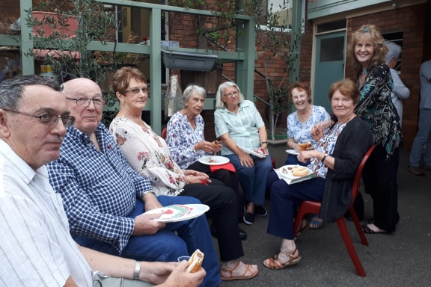
PARISH CHRISTMAS GET TOGETHER
A big thank you to everyone who attended our Christmas get together hosted by Fathers Greg and Andrew. The night was a great success and we hope all had a lovely evening.

THANK YOU FROM CATHOLIC MISSIONS
Catholic Mission would like to offer their heart-felt thanks for your generous response to the Appeal held in late October. Tax receipts will be issued and sent by Catholic Mission.

SCHOOL END OF YEAR CONCERT
On Tuesday 11th December from 5:00pm, Sacred Heart Primary School will be hosting their end of year Christmas Concert. This will involve the singing of Christmas songs as well as playing out the Nativity Scene. Parishioners are welcome to attend.

CATHOLIC CEMETARIES AND CREMATORIA
Catholic Cemeteries and Crematoria warmly invites you and your family to join them at the annual Twilight Carols at Mary, Mother of Mercy Chapel, Rookwood Catholic Cemetery on Thursday 13th December 2018, commencing at 6:30pm. Fireworks to follow at 9pm.
Catholic Cemeteries and Crematoria also wish to extend the invitation to join them at the annual Christmas Remembrance Service 2018, presided by Bishop Terence Brady at St Mary’s Cathedral Sydney on Sunday 16th December 2018 commencing at 7:30pm

A CHORAL CHRISTMAS CELEBRATION CONCERT
On Friday 14 December, St Mary’s Cathedral will celebrate with carols and Christmas joy for the annual, and much anticipated ‘A Choral Christmas Celebration’ concert. There will be two performances at 11am & 7pm with tickets starting from $20. For more information, visit www.cathedralchoir.sydney/accc
AN ADVENT APP FOR CHRISTMAS – MEET ME IN THE SILENCE
Walk the journey to Advent on your mobile device. Each day delivers a new video, podcast or written feature to assist you prepare for Christmas and meet Jesus in the silence, despite the busyness of the Christmas season.
The Advent Calendar App is free and available on your iPhone, iPad and Android devices. Search for "Xt3 Advent" in the Google Play store or the App store, or visit ww.sydneycatholic.org/xt3advent

BUSINESS MANAGER POSITION
St Charbel’s College at Punchbowl is seeking a CA or CPA qualified accountant for a full-time role as its Business Manager. If interested, contact Mr Greg Smith on 0404 607870

CATHOLICCARE HOME CARE PACKAGES
CatholicCare provides services in your home to help you live independently. From occasional or short-term services to round-the-clock options, CatholicCare can help you decide on services to meet your individual needs. For more information, please contact CCareline on 13 18 19.

CATHOLIC EDUCATION FUNDING
Would you like to receive a quality Catholic Education for your child? Is the cost of sending your child to a Catholic School holding you back from this? We are here to assist you however we can.
Do you live in government housing? Do you hold a current Health Care Card? Is your only source of income Centrelink? You could be eligible for heavily reduced fees.
If you don’t satisfy the above eligibility no need to panic, you still may be eligible for a reduction in your child’s school fees, if you are a low income worker. We will also help you set up payment plans for the small amount of fees you may be required to pay. All you will need to do is ask and our staff at your local Sydney Catholic School will be ready to assist you with this process, with the upmost of confidentiality.
For enquiries, please contact Sydney Catholic Schools, Southern Region Office, Mr Simon Wilson (Professional Officer, Assistant to the Regional Director) on (02) 9772 7000.

