SACRED HEART CHURCH

120 Carawatha Street Villawood

Telephone: (02) 9644-4026 Email: office@ihmsefton.org.au

Administrator: Fr Greg McGregor

Assistant Priest: Fr Thomas Alukka

SUNDAY MASS: Sunday: 9:00am

WEEKDAY MASSES: Tuesday to Friday – 8:00am

CONFESSIONS: On Request

**Sunday, 4 Nov 2018: Thirty-First Sunday in Ordinary Time - Year B**

**ENTRANCE ANTIPHON**: Forsake me not, O Lord, my God; be not far from me! Make haste and come to my help, O Lord, my strong salvation!

**RESPONSORIAL PSALM**: I love you Lord, my strength.

**GOSPEL ACCLAMATION:** **Alleluia, alleluia!** All who love me will keep my words, and my Father will love them and we will come to them. **Alleluia!**

**COMMUNION ANTIPHON:** You will show me the path of life, the fullness of joy in your presence, O Lord.

**VILLAWOOD MASSES:**

**Monday – 5th November** 31st Week in Ordinary Time. No Mass

**Tuesday – 6th November** 31st Week in Ordinary Time. Mass 8:00am

**Wednesday – 7th November** 31st Week in Ordinary Time. Mass 8:00am

**Thursday – 8th November** 31st Week in Ordinary Time. Mass 8:00am

**Friday – 9th November** The Dedication of the Lateran Basilica. Mass 8:00am

**Saturday – 10th November** St Leo the Great. No Mass

**Sunday – 11th November** 32nd Sunday in Ordinary Time. Mass 9:00am

**SEFTON MASSES:**

**Monday to Friday** 9:15am

**Saturday** 9:15am, 5:30pm (Vigil)

**Sunday** 8:00am, 10:00am, 5:30pm

Total of both collections last Sunday: $330 Catholic Mission $60

**WELCOME BACK FATHER THOMAS**

Welcome back to Father Thomas as he returns from his annual leave. We hope the break has provided refreshment and relaxation! With this news, Mass times at Sacred Heart will return to Tuesday to Friday at 8:00am as well as Sunday 9:00am.

**CATHOLIC MISSIONS APPEAL**

**Thank you** for your generosity last weekend to support the people of Myanmar build their nation for future generations.

**CATHOLIC WEEKLY - PULPIT POINTS 4TH NOVEMBER 2018**

• East meets West: Adoration under the stars

• Red is for the persecuted

• North Bondi man is NRL teacher of the year

• Sinister schools agenda: Pat Byrne

• Movie review: Halloween

• Popes new book

*Available in the foyer. $2 – all money goes to the poor.*

**BAPTISM**



Please pray for LOUIS WEN as we welcome him into our parish

community through the sacrament of baptism on Sunday, 11th November

2018. Let us pray also for his parents and godparents, that the Lord may

help them in raising Louis in the practice of the faith.

**CWF APPEAL**

This weekend, **Sunday 4th November**, your Parish will be asked to play an important role in supporting an important initiative of the Sydney Archdiocese: The Charitable Works Fund (CWF) Pastoral Appeal, our premier charity. Appeal envelopes will be provided for your use so please keep an eye out for them. Let us show our Christian solidarity for one another by sharing what we can with our neighbours. Thank you.

**WELCOME BEN!**

From November 27th, we are blessed to have a seminarian join our Sefton and Villawood communities for six months. Please make welcome **Ben** as he shares in Masses and other events with our communities.

**CATHOLICCARE PRESENTATION**

You don’t have to work out the home care system on your own. Staying independent in your own home is a priority for many Australian Seniors. CatholicCare’s Home Care Specialists can guide you through the complicated government systems.  Join us and find out how to access in-home support and caring services.

**When:** Wednesday 7th November 10:00am (share a cuppa from 9:30am)

**Where:** Immaculate Heart of Mary Parish Sefton - Oblate Rooms (next to Church)

**RSVP:** Parish Office: 9644-4026

***Who should attend?*** Seniors (even those who don’t need home care today); their friends and family; and community members who have regular contact with Seniors and may be able to help them get a start with organising home care.

**PLENARY COUNCIL MEETING FOR THE SEFTON AND VILLAWOOD PARISHES**

As you may be aware, the Church in Australia has initiated the Plenary Council 2020 to allow each person to communicate their story and experience of faith and the Church. For our Villawood and Sefton parishes, a meeting has been organised after the 10am Mass at Sefton Church on Sunday 18th November in the meeting room (Oblate room). This is an opportunity for people to create time and space to consider the question; “What do you think God is asking of us in Australia at this time?” Please join our community on Sunday 18th November to discuss the role you and your Parish can play in helping the Church in Australia. Thank you.

**CHECK OUT THE ARCHDIOCESE OF SYDNEY’S NEW WEBSITE**

The Archdiocese has launched a fresh new-look website with all the latest news and information from across the archdiocese and the Church in Australia. From video to podcasts to links to social media where you can have your say on Catholic issues and share richer online content with friends and family, the new site also promotes major events across the archdiocese, regular updates from Archbishop Anthony Fisher as well as providing practical information for Catholics on Mass times, the sacraments and locating clergy and Catholic schools. Visit the new-look site at <https://www.sydneycatholic.org/>

**PRISON SUNDAY – NOVEMBER 11 2018**

Prison Sunday commenced in 2016, during the Year of Mercy, as an initiative of Pope Francis

to observe the Jubilee for Prisoners. This year, inspired by the Australian Catholic Church’s Year of Youth, the focus of Prison Sunday will be youth justice and juvenile detention on Sunday, November 11. Bishop Terry Brady said youth detention systems in some Australian states and territories were under significant stress, leaving vulnerable young people without the services they need to turn their lives around. Please observe Prison Sunday and keep the youth in your prayers.

**SYDNEY CATHOLIC MEN’S MINISTRY NETWORK MEETING**

Calling all Men! We all need the supportive brotherhood of other good men. Come and find out more about men’s ministry in Sydney archdiocese. Find out how you can start or join a local men’s group in your area with support from us. Hosted by Bishop Richard Umbers, hear from Tristan Ross, former lieutenant in the army on his experience of Catholic brotherhood. Ben Galea from Young Men of God will facilitate a discussion on growing new men’s groups. **Friday night November 23**, ***6.30pm*** *Mass,* ***7.30pm*** *Dinner,* ***8.30pm*** *Presentations*. St. Paul of the Cross Parish, 532 New Canterbury Rd, Dulwich Hill. Register: www.trybooking.com/431767 More Info: christopher.gordon@sydneycatholic.org

**THE BISHOP’S BLEND**

Bishop Richard Umbers is hosting the sixth edition of a series of breakfast events for young professions, titled **The Bishop’s Blend, on Thursday, 15 November 2018 at 7:00am**. The purpose of these events is to bring young Catholic professionals together for a quarterly breakfast, for them to hear from a well-versed professional on how they live out their faith in the workplace. It will also be an opportunity for attendees to network with other young Catholic professionals.

**ST VINCENT DE PAUL NIGHT PATROL**

The St Vincent de Paul Society’s, Liverpool Night Patrol is a homeless food service operating **Tuesday-Saturday night, within the Liverpool local Government Area** and is a part of the Sydney Vinnies Van Services. It provides sandwiches, blankets, toiletries, hot beverages and most importantly, companionship to people experiencing or at risk of homelessness. Liverpool Night Patrol is currently in need of volunteers to join our teams on an ongoing basis to help make our service possible. Volunteers make a once a month commitment and **shifts run from 8pm until 10.30pm**. If you are interested in joining, we have a training session coming up on **Monday 19 November in Liverpool**. Please email liverpoolnightpatrol@sydneyvinnies.org for information.



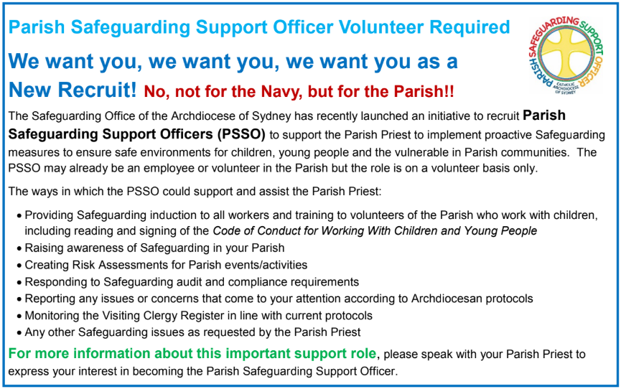



**THE CATHOLIC ARCHDIOCESE OF SYDNEY SAFEGUARDING OFFICE**

If you or a person close to you has been abused by someone working or ministering within the Archdiocese of Sydney we invite you to contact us. We will listen to you respectfully, offer support and discuss the options you have available to you. Please contact the Safeguarding and Ministerial Integrity Office on **ph 02 9390 5812**.