SACRED HEART CHURCH

120 Carawatha Street Villawood

Telephone: (02) 9644-4026 Email: office@ihmsefton.org.au

Administrator: Fr Greg McGregor

Assistant Priest: Fr Thomas Alukka

SUNDAY MASS: Sunday: 9:00am

WEEKDAY MASSES: Tuesday to Friday – 8:00am

CONFESSIONS: On Request

**Sunday, 11 Nov 2018: Thirty-Second Sunday in Ordinary Time - Year B**

**ENTRANCE ANTIPHON**: Let my prayer come into your presence. Incline your ear to my cry for help, O Lord.

**RESPONSORIAL PSALM**: Praise the Lord, my soul!

**GOSPEL ACCLAMATION:** **Alleluia, alleluia!** Happy the poor in spirit; the kingdom of heaven is theirs. **Alleluia!**

**COMMUNION ANTIPHON:** The Lord is my shepherd; there is nothing I shall want. Fresh and green are the pastures where he gives me repose, near restful waters he leads me.

**VILLAWOOD MASSES:**

**Monday – 12th November** St Josephat. No Mass

**Tuesday – 13th November** 32nd Week in Ordinary Time. Mass 8:00am

**Wednesday – 14th November** 32nd Week in Ordinary Time. Mass 8:00am

**Thursday – 15th November** St Albert the Great. Mass 8:00am

**Friday – 16th November** St Margaret of Scotland & St Gertrude. Mass 8:00am

**Saturday – 17th November** St Elizabeth of Hungary. No Mass

**Sunday – 18th November** 33rd Sunday in Ordinary Time. Mass 9:00am

**SEFTON MASSES:**

**Monday to Friday** 9:15am

**Saturday** 9:15am, 5:30pm (Vigil)

**Sunday** 8:00am, 10:00am, 5:30pm

Total of both collections last Sunday: $403.30 CWF $210.00

**MASS TIMES**

Please note Mass times at Sacred Heart will return to **Tuesday to Friday at 8:00am** as well as **Sunday 9:00am**.

**CWF APPEAL**

**Thank you** for your generosity last weekend in supporting the CWF appeal. *To give is to trust in God, His love that embraces us all and His power to provide.*

**CATHOLIC WEEKLY - PULPIT POINTS 11TH NOVEMBER 2018**

• All Saints leads the way

• Pinned by the logic of life

• Archbishop Fisher: The good, the bad and the odd

• Pakistan caves in on Asia Bibi

• Movie review: *The Nutcracker and the Four Realms*

• Christous Rex Pilgrimage

*Available in the foyer. $2 – all money goes to the poor.*

**BAPTISM**



Please pray for **LOUIS WEN** as we welcome him into our parish

community through the sacrament of baptism on Sunday, 11th November

2018. Let us pray also for his parents and godparents, that the Lord may

help them in raising Louis in the practice of the faith.

**PLENARY COUNCIL MEETING FOR THE SEFTON AND VILLAWOOD PARISHES**

As you may be aware, the Church in Australia has initiated the Plenary Council 2020 to allow each person to communicate their story and experience of faith and the Church. For our Villawood and Sefton parishes, a meeting has been organised **after the 10am Mass** **at Sefton Church on Sunday** **18th November in the meeting room (Oblate room)**. This is an opportunity for people to create time and space to consider the question; “What do you think God is asking of us in Australia at this time?” Please join our community on Sunday 18th November to discuss the role you and your Parish can play in helping the Church in Australia. Thank you.

**CHECK OUT THE ARCHDIOCESE OF SYDNEY’S NEW WEBSITE**

The Archdiocese has launched a fresh new-look website with all the latest news and information from across the archdiocese and the Church in Australia. From video to podcasts to links to social media where you can have your say on Catholic issues and share richer online content with friends and family, the new site also promotes major events across the archdiocese, regular updates from Archbishop Anthony Fisher as well as providing practical information for Catholics on Mass times, the sacraments and locating clergy and Catholic schools. Visit the new-look site at <https://www.sydneycatholic.org/>

**PRISON SUNDAY – NOVEMBER 11 2018**

Prison Sunday commenced in 2016, during the Year of Mercy, as an initiative of Pope Francis

to observe the Jubilee for Prisoners. This year, inspired by the Australian Catholic Church’s Year of Youth, the focus of Prison Sunday will be youth justice and juvenile detention on Sunday, November 11. Bishop Terry Brady said youth detention systems in some Australian states and territories were under significant stress, leaving vulnerable young people without the services they need to turn their lives around. Please observe Prison Sunday and keep the youth in your prayers.

**MASS FOR PREGNANT MOTHERS**

Are you expecting a baby or know someone who is? You are warmly invited to attend the annual Mass for Pregnant Mothers to be celebrated by Most Rev Richard Umbers, Auxiliary Bishop of Sydney, at St Mary’s Cathedral on **Sunday 18th of November at 10:30am.** RSVP and enquiries can be directed to LMFevents@sydneycatholic.org or call 9307-8401.

**THE BISHOP’S BLEND**

Bishop Richard Umbers is hosting the sixth edition of a series of breakfast events for young professionals, titled **The Bishop’s Blend, on Thursday, 15 November 2018 at 7:00am**. The purpose of these events is to bring young Catholic professionals together for a quarterly breakfast, for them to hear from a well-versed professional on how they live out their faith in the workplace. It will also be an opportunity for attendees to network with other young Catholic professionals.

**SYDNEY CATHOLIC MEN’S MINISTRY NETWORK MEETING**

Calling all Men! We all need the supportive brotherhood of other good men. Come and find out more about men’s ministry in Sydney archdiocese. Find out how you can start or join a local men’s group in your area with support from us. Hosted by Bishop Richard Umbers, hear from Tristan Ross, former lieutenant in the army on his experience of Catholic brotherhood. Ben Galea from Young Men of God will facilitate a discussion on growing new men’s groups. **Friday night November 23**, ***6.30pm*** *Mass,* ***7.30pm*** *Dinner,* ***8.30pm*** *Presentations*. St. Paul of the Cross Parish, 532 New Canterbury Rd, Dulwich Hill. Register: www.trybooking.com/431767 More Info: christopher.gordon@sydneycatholic.org

**ST VINCENT DE PAUL NIGHT PATROL**

The St Vincent de Paul Society’s, Liverpool Night Patrol is a homeless food service operating **Tuesday-Saturday night, within the Liverpool local Government Area** and is a part of the Sydney Vinnies Van Services. It provides sandwiches, blankets, toiletries, hot beverages and most importantly, companionship to people experiencing or at risk of homelessness. Liverpool Night Patrol is currently in need of volunteers to join our teams on an ongoing basis to help make our service possible. Volunteers make a once a month commitment and **shifts run from 8pm until 10.30pm**. If you are interested in joining, we have a training session coming up on **Monday 19 November in Liverpool**. Please email liverpoolnightpatrol@sydneyvinnies.org for information.

**LOURDES DAY MASS 2018**

On **Saturday, 1st December 2018 at 10am,** the Order of Malta are holding their annual Lourdes Day Mass at **St Mary’s Cathedral, Sydney.** The Mass is open to all, but in particular those who are sick or infirm and may wish to receive a special blessing. Please find leaflets at the back of the Church for more information.

**BUSINESS MANAGER POSITION**

St Charbel’s College at Punchbowl is seeking a CA or CPA qualified accountant for a full-time role as its Business Manager. If interested, contact **Mr Greg Smith on 0404 607870**

**CATHOLICCARE HOME CARE PACKAGES**

CatholicCare provides services in your home to help you remain living independently. From occasional or short-term services to round-the-clock options, CatholicCare can help you decide on the services to meet your individual needs. For more information please contact the CCareline on 13 18 19.

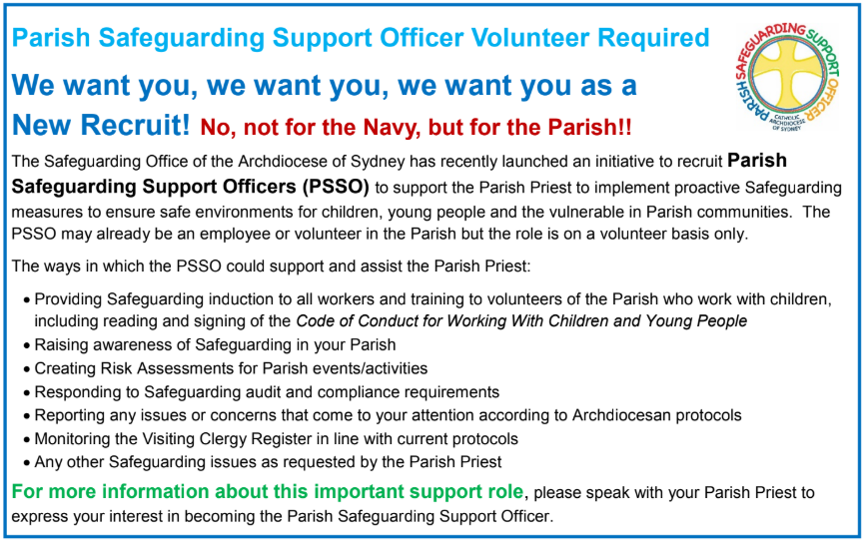



**THE CATHOLIC ARCHDIOCESE OF SYDNEY SAFEGUARDING OFFICE**

If you or a person close to you has been abused by someone working or ministering within the Archdiocese of Sydney we invite you to contact us. We will listen to you respectfully, offer support and discuss the options you have available to you. Please contact the Safeguarding and Ministerial Integrity Office on **ph 02 9390 5812**.