SACRED HEART CHURCH
120 Carawatha Street Villawood
Telephone: (02) 9644-4026 Email: office@ihmsefton.org.au

Administrator: Fr Greg McGregor
Assistant Priest: Fr Thomas Alukka, Fr Andrew Feng

SUNDAY MASS: Sunday: 9:00am
WEEKDAY MASSES: Tuesday to Friday – 8:00am
CONFESSIONS: On Request
BAPTISMS: Contact Parish Office

Sunday, 18 Nov 2018: Thirty-Third Sunday in Ordinary Time - Year B

ENTRANCE ANTIPHON: The Lord said: I think thoughts of peace and not of affliction. You will call upon me, and I will answer you, and I will lead back your captives from every place.

RESPONSORIAL PSALM: Keep me safe, O God: you are my hope.

GOSPEL ACCLAMATION: Alleluia, alleluia! Be watchful, and pray constantly, that you may be worthy to stand before the Son of Man. Alleluia!

COMMUNION ANTIPHON: To be near God is my happiness, to place my hope in God the Lord.

VILLAWOOD MASSES:
Monday – 19th November 33rd Week in Ordinary Time. No Mass
Tuesday – 20th November 33rd Week in Ordinary Time. Mass 8:00am
Wednesday – 21st November The Presentation of the Blessed Virgin Mary. Mass 8:00am
Thursday – 22nd November St Cecilia. Mass 8:00am
Friday – 23rd November St Clement I & St Columban. Mass 8:00am
Saturday – 24th November Sts Andrew Dung-Lac & companions. No Mass
Sunday – 25th November Our Lord Jesus Christ, King Of The Universe. Mass 9:00am

SEFTON MASSES: INDIAN MASSES AT VILLAWOOD:
Monday to Friday 9:15am Tuesday to Friday 7:00pm
Saturday 9:15am, 5:30pm (Vigil) Saturday 9:30am
Sunday 8:00am, 10:00am, 5:30pm Sunday 10:15am

Total of both collections last Sunday: $470.80

WELCOME FATHER ANDREW FENG AND BEN THE SEMINARIAN!
Please welcome Fr Andrew Feng as he joins our Sefton and Villawood Parishes. He will be assisting Fr Greg and Fr Thomas with Masses and other Parish events. Additionally, Ben the seminarian will be joining our communities from next week. Please make welcome Ben and Fr Andrew.

PRAY FOR VARGHESE ALUKKA
Please keep Fr Thomas’ dad in your thoughts and prayers as he has been moved to ICU in India.
CATHOLIC WEEKLY - PULPIT POINTS 18TH NOVEMBER 2018
• Mary & Frederik visit Francis
• Remembering the fallen: Surry Hills
• Bring the family! Lights of Christmas
• Students’ changing religious attitudes
• Movie review: Dr Seuss’s The Grinch
• The Marine & the Charismatic who became Deacons
Available in the foyer. $2 – all money goes to the poor.

HALL USAGE
If you use the Church hall, please contact the Parish office on 9644 4026 for future bookings. Thank you.

PLENARY COUNCIL MEETING FOR SEFTON AND VILLAWOOD PARISHES
As you may be aware, the Church in Australia has initiated the Plenary Council 2020 to allow each person to communicate their story and experience of faith and the Church. For our Villawood and Sefton parishes, a meeting has been organised after the 10am Mass at Sefton Church on Sunday 18th November in the meeting room (Oblate room). This is an opportunity for people to create time and space to consider the question; “What do you think God is asking of us in Australia at this time?” Please join our community on Sunday 18th November to discuss the role you and your Parish can play in helping the Church in Australia.

CHECK OUT THE ARCHDIOCESE OF SYDNEY’S NEW WEBSITE
The Archdiocese has launched a fresh new-look website with all the latest news and information from across the archdiocese and the Church in Australia. From video to podcasts to links to social media where you can have your say on Catholic issues and share richer online content with friends and family, the new site also promotes major events across the archdiocese, regular updates from Archbishop Anthony Fisher as well as providing practical information for Catholics on Mass times, the sacraments and locating clergy and Catholic schools. Visit the new-look site at https://www.sydneycatholic.org/

PARISH CHRISTMAS GET TOGETHER
An invitation is extended from Fathers Greg, Thomas and Andrew to join them at the Sefton Presbytery on the 5th of December for a Christmas ‘Get-Together’. Everyone who has helped and supported our Parish over the last year, feel free to come for a few minutes or a few hours for food and drinks.

SYDNEY CATHOLIC MEN’S MINISTRY NETWORK MEETING
Calling all Men! We all need the supportive brotherhood of other good men. Come and find out more about men’s ministry in Sydney archdiocese. Find out how you can start or join a local men’s group in your area with support from us. Hosted by Bishop Richard Umbers, hear from Tristan Ross, former lieutenant in the army on his experience of Catholic brotherhood. Ben Galea from Young Men of God will facilitate a discussion on growing new men’s groups. Friday night November 23, 6.30pm Mass, 7.30pm Dinner, 8.30pm Presentations. St. Paul of the Cross Parish, 532 New Canterbury Rd, Dulwich Hill. Register: www.trybooking.com/431767 More Info: christopher.gordon@sydneycatholic.org

ST VINCENT DE PAUL NIGHT PATROL
The St Vincent de Paul Society’s, Liverpool Night Patrol is a homeless food service operating Tuesday-Saturday night, within the Liverpool local Government Area and is a part of the Sydney Vinnies Van Services. It provides sandwiches, blankets, toiletries, hot beverages and most importantly, companionship to people experiencing or at risk of homelessness. Liverpool Night Patrol is currently in need of volunteers to join our teams on an ongoing basis to help make our service possible. Volunteers make a once a month commitment and shifts run from 8pm until 10.30pm. If you are interested in joining, we have a training session coming up on Monday 19 November in Liverpool. Please email liverpoolnightpatrol@sydneyvinnies.org for information.

MEMORIAL MASS FOR DECEASED PRIESTS
All parishioners are invited to attend the Annual Memorial Mass for Deceased Priests, celebrated by Bishop Terry Brady. The mass will be held on Wednesday, 21st November at 12pm at Mary, Mother of Mercy Chapel, Rookwood Catholic Cemetery. Light refreshments will follow in the Mary, Mother of Mercy Condolence Lounge. Please RSVP by 15th November to Nancy Murdocca by either phone: 9646 6908 or email: nancym@catholiccemeteries.com.au

LOURDES DAY MASS 2018
On Saturday, 1st December 2018 at 10am, the Order of Malta are holding their annual Lourdes Day Mass at St Mary’s Cathedral, Sydney. The Mass is open to all, but in particular those who are sick or infirm and may wish to receive a special blessing. Please find leaflets at the back of the Church for more information.

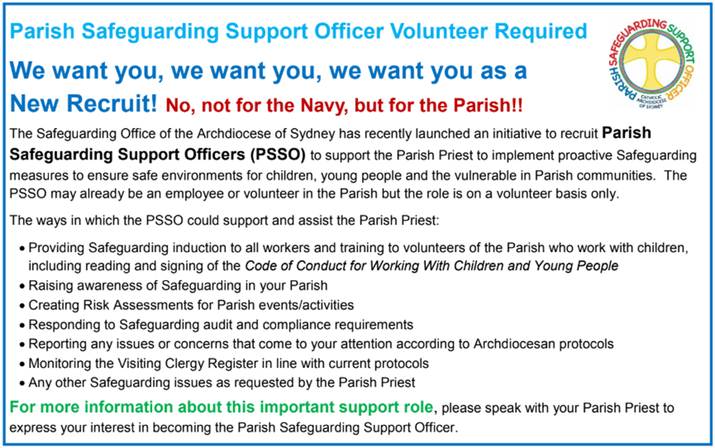

BUSINESS MANAGER POSITION
St Charbel’s College at Punchbowl is seeking a CA or CPA qualified accountant for a full-time role as its Business Manager. If interested, contact Mr Greg Smith on 0404 607870

CATHOLICCARE HOME CARE PACKAGES
CatholicCare provides services in your home to help you live independently. From occasional or short-term services to round-the-clock options, CatholicCare can help you decide on services to meet your individual needs. For more information, please contact CCareline on 13 18 19.

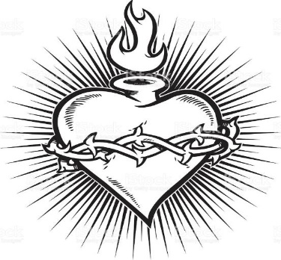

THE CATHOLIC ARCHDIOCESE OF SYDNEY SAFEGUARDING OFFICE
If you or a person close to you has been abused by someone working or ministering within the Archdiocese of Sydney we invite you to contact us. We will listen to you respectfully, offer support and discuss the options you have available to you. Please contact the Safeguarding and Ministerial Integrity Office on ph 02 9390 5812.

