SACRED HEART CHURCH
120 Carawatha Street Villawood
Telephone: (02) 9644-4026 Email: office@ihmsefton.org.au

Administrator: Fr Greg McGregor
Assistant Priest: Fr Thomas Alukka

SUNDAY MASS: Sunday: 9:00am
WEEKDAY MASSES: Wednesday and Friday – 8:00am
CONFESSIONS: On Request

Sunday, 7 Oct 2018: Twenty-Seventh Sunday in Ordinary Time - Year B

ENTRANCE ANTIPHON: Within your will, O Lord, all things are established, and there is none that can resist your will. For you have made all things, the heaven and the earth, and all that is held within the circle of heaven; you are the Lord of all.

RESPONSORIAL PSALM: May the Lord bless us all the days of our lives.

GOSPEL ACCLAMATION: Alleluia, alleluia! If we love one another, God will live in us in perfect love. Alleluia!

COMMUNION ANTIPHON: The Lord is good to those who hope in him, to the soul that seeks him.

VILLAWOOD MASSES:
Monday – 8th October 27th Week in Ordinary Time. No Mass
Tuesday – 9th October Sts Denis & John Leonardi. No Mass
Wednesday – 10th October 27th Week in Ordinary Time. Mass 8:00am
Thursday – 11th October Pope St John XXIII. No Mass
Friday – 12th October 27th Week in Ordinary Time. Mass 8:00am
Saturday – 13th October Saturday Mass of the Virgin Mary. No Mass
Sunday – 14th October 28th Sunday in Ordinary Time. Mass 9:00am

SEFTON MASSES:
Monday to Friday 9:15am
Saturday 9:15am, 5:30pm (Vigil)
Sunday 8:00am, 10:00am, 5:30pm

Total of both collections last Sunday: $404.35

ANNUAL LEAVE
We welcome Fr Greg back as he returns this week from annual leave. We thank Fr Tom Stevens (Liverpool Parish) who has been helping out during this time. Fr Thomas will commence his annual leave next week. We wish Fr Thomas a safe and relaxing break, and thank Fr Gerry as he returns to Villawood to assist Fr Greg during this time.
Masses at Villawood will continue to be limited to Wednesday and Friday at 8:00am and Sunday at 9:00am. All parishioners are welcome to attend any of the masses at Sefton parish.

CATHOLIC WEEKLY - PULPIT POINTS 7TH OCTOBER 2018
• 24,000 km solo trip to absolve sin
• NEW LOOK Catholic Weekly - Win an iPad
• Olympics Bound: Students to compete in Argentina
• Growing threat to Seal of Confession
• Movie review: Smallfoot
Available in the foyer. $2 – all money goes to the poor.

SACRAMENTAL DATES FOR 2018
The Sacrament of First Holy Communion for the Sacred Heart parish will be held on Sunday 21st October at 10:30am.

CHECK OUT THE ARCHDIOCESE OF SYDNEY’S NEW WEBSITE
The Archdiocese has launched a fresh new-look website with all the latest news and information from across the archdiocese and the Church in Australia. From video to podcasts to links to social media where you can have your say on Catholic issues and share richer online content with friends and family, the new site also promotes major events across the archdiocese, regular updates from Archbishop Anthony Fisher as well as providing practical information for Catholics on Mass times, the sacraments and locating clergy and Catholic schools. Visit the new-look site at https://www.sydneycatholic.org/

OF LIFE AND LOVE – PRE-MARRIAGE COURSE
This excellent course for engaged couples gives particular emphasis to the spiritual and sacramental dimensions of marriage, while also paying due attention to the practical elements as well. It highlights the importance of God’s grace and human love in building a happy relationship, and it suggests ways in which married love can grow over the years. Topics include the beauty of Christian marriage, openness to life, family of origin, communication and the nuptial paradigm. An approved course for marriage preparation in the Catholic Church.
October 17, 24 and 31, 7-10pm, Assisi Centre, Catholic Education Office, behind St. Joachim’s Parish, 3 Keating St. Lidcombe. More Info: Life, Marriage and Family Sydney Ph: 9307 8400 or E: LMFevents@sydneycatholic.org or to register: www.trybooking.com/book/event?eid=335146&

DEVOTIONS TO HONOUR OUR LADY OF LOURDES
Mass and Blessing of the Sick will be held at Our Lady of Lourdes Grotto, Earlwood, on Sunday, 14th October 2018 (behind Our Lady of Lourdes Church, Earlwood), entrance via St. James Avenue, Earlwood, commencing with recitation of the Rosary at 2:30 p.m. followed by Mass and the Blessing of the Sick at 3:00 p.m. The Principal celebrant will be Bishop Peter Ingham, Emeritus Bishop of Wollongong. Some parking for disabled people is available in the school grounds and general parking in the nearby council car park.

NCC SYDNEY ANNUAL FUNDRAISING DINNER 2018
Join us as we celebrate the year’s achievements and hear from guest speaker, Mark Latham, on Friday, 12th October 2018 at 7:00pm. The function will be held at The Epping Club, 45-47 Rawson Street, Epping, NSW 2121. Tickets can be booked online at www.trybooking.com/xzxz

PLENARY COUNCIL 2020
The Plenary Council 2020 is a gathering of the Church in Australia to make decisions for the future.
How you can be involved:
- Talk with your parish priest about becoming a parish ambassador or to know more contact 9390 5100 or plenarycouncil@sydneycatholic.org
- Look out for a listening and dialogue session near you, or for more details contact 9390 5100, or plenarycouncil@sydneycatholic.org
- Make an individual and direct response to the national Plenary Council, via: http://plenarycouncil.catholic.org.au/resources/have-your-say/
- Share your response with the Archdiocese of Sydney, via: plenarycouncil@sydneycatholic.org
Want to know more? Watch the videos at: http://plenarycouncil.catholic.org.au/resources/watch/

MURDER IN THE CATHEDRAL
Artes Christi presents T. S. Eliot’s play of St Thomas Becket, directed by internationally acclaimed actor and writer, Donald Macdonald. The play is being staged to coincide with the Canonisation of Archbishop Oscar Romero who was the first Archbishop since Becket to be martyred at the altar. The play is also supporting persecuted people today via Aid to the Church in Need. Shows from the 27th September to the 14th October at 1880 Hall, St Peter’s Surry Hills. Group tickets from $30. Bookings are essential via www.theword.org.au or 1800 101 201.

BE AWAKE NATIONAL CATHOLIC MEN'S CONFERENCE
“Be Awake; stand firm in the faith; be courageous; be strong.” 1 Cor 16:13-16
“Where are you men of God? Are you AWAKE?” MenAlive and the Young Men of God Movement have united to host a life-changing event for the men of this nation from 19th to 21st October. The conference will bring the very best of MenAlive’s hugely successful MAX conference, and the unrivalled strength of the Young Men of God National Conference. There is nothing like the journey of growing in faith alongside your brothers. There will be great speakers, worship, prayer, sacraments, sports and brotherhood time. Be inspired, be transformed at this extraordinary event not to be missed! To register go to menalive.org.au or ymgmovement.org

Volunteer with Palms Australia- Teachers always required!
East Timor needs Teachers – Ready to take your skills to new heights in the mountains of Timor? Contact Christine on 02 9560 5333.
The parish and school community of Hatubulico have requested two volunteers:
a Secondary Teacher/Mentor and a Community Development Mentor.

For more opportunities, visit palms.org.au/volunteer

Can’t commit just yet but would like a look? Try a short Encounter tour to Timor Leste or Samoa-
Call us 02 9560 5333 or go to palms.org.au/encounters
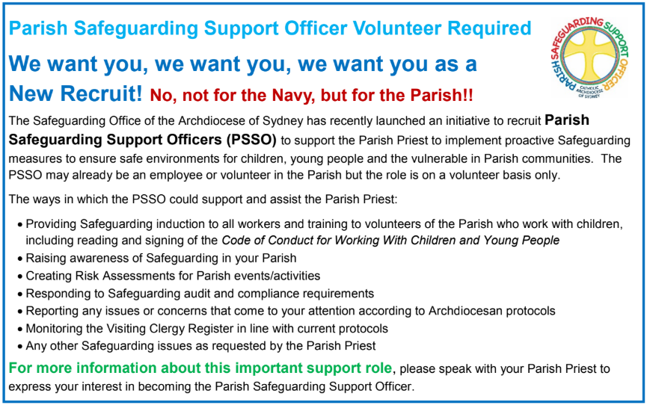

CATHOLICCARE HOME CARE PACKAGES
CatholicCare provides services in your home to help you remain living independently. From occasional or short-term services to round-the-clock options, CatholicCare can help you decide on the services to meet your individual needs. For more information please contact the CCareline on 13 18 19.

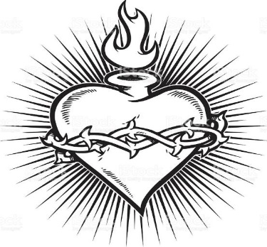

THE CATHOLIC ARCHDIOCESE OF SYDNEY SAFEGUARDING OFFICE
If you or a person close to you has been abused by someone working or ministering within the Archdiocese of Sydney we invite you to contact us. We will listen to you respectfully, offer support and discuss the options you have available to you. Please contact the Safeguarding and Ministerial Integrity Office on ph 02 9390 5812.

