SACRED HEART CHURCH
120 Carawatha Street Villawood
Telephone: (02) 9644-4026 Email: office@ihmsefton.org.au

Administrator: Fr Greg McGregor
Assistant Priest: Fr Thomas Alukka

SUNDAY MASS: Sunday: 9:00am
WEEKDAY MASSES: Wednesday and Friday – 8:00am
CONFESSIONS: On Request

Sunday, 14 Oct 2018: Twenty-Eighth Sunday in Ordinary Time - Year B

ENTRANCE ANTIPHON: If you, O Lord, should mark iniquities, Lord, who could stand? But with you is found forgiveness, O God of Israel.

RESPONSORIAL PSALM: Fill us with your love, O Lord, and we will sing for joy!

GOSPEL ACCLAMATION: Alleluia, alleluia! Happy the poor in spirit; the kingdom of heaven is theirs! Alleluia!

COMMUNION ANTIPHON: When the Lord appears, we shall be like him, for we shall see him as he is.

VILLAWOOD MASSES:
Monday – 15th October St Teresa of Jesus. No Mass
Tuesday – 16th October Sts Hedwig & Margaret Mary Alacoque. No Mass
Wednesday – 17th October St Ignatius of Antioch. Mass 8:00am
Thursday – 18th October St Luke Pope. No Mass
Friday – 19th October Sts Paul of the Cross, John de Brébeuf & Isaac Jogues. Mass 8:00am
Saturday – 20th October Saturday Mass of the Virgin Mary. No Mass
Sunday – 21st October 29th Sunday in Ordinary Time. Mass 9:00am

SEFTON MASSES:
Monday to Friday 9:15am
Saturday 9:15am, 5:30pm (Vigil)
Sunday 8:00am, 10:00am, 5:30pm

Total of both collections last Sunday: $329.60

ANNUAL LEAVE
Fr Thomas will commence his annual on Monday. We wish Fr Thomas a safe and relaxing break, and thank Fr Gerry as he returns to Villawood to assist Fr Greg during this time.
Masses at Villawood will continue to be limited to Wednesday and Friday at 8:00am and Sunday at 9:00am. All parishioners are welcome to attend any of the masses at Sefton parish.

CATHOLIC WEEKLY - PULPIT POINTS 14TH OCTOBER 2018
• Archbishop apologises to youth
• NEW LOOK Catholic Weekly - Win an iPad
• Oullet answers Vigano
• Dominican Sister’s joy
• Movie review: A Star is Born
Available in the foyer. $2 – all money goes to the poor.

SACRAMENTAL DATES FOR 2018
The Sacrament of First Holy Communion for the Sacred Heart parish will be held on Sunday 21st October at 10:30am.

CATHOLIC MISSIONS APPEAL
The Catholic Missions Appeal will be held on the weekend of the 20th and 21st October, which happens to coincide with World Mission Day. Please give generously to support our Catholic Missions. Thank you.

CHECK OUT THE ARCHDIOCESE OF SYDNEY’S NEW WEBSITE
The Archdiocese has launched a fresh new-look website with all the latest news and information from across the archdiocese and the Church in Australia. From video to podcasts to links to social media where you can have your say on Catholic issues and share richer online content with friends and family, the new site also promotes major events across the archdiocese, regular updates from Archbishop Anthony Fisher as well as providing practical information for Catholics on Mass times, the sacraments and locating clergy and Catholic schools. Visit the new-look site at https://www.sydneycatholic.org/

OF LIFE AND LOVE – PRE-MARRIAGE COURSE
This excellent course for engaged couples gives particular emphasis to the spiritual and sacramental dimensions of marriage, while also paying due attention to the practical elements as well. It highlights the importance of God’s grace and human love in building a happy relationship, and it suggests ways in which married love can grow over the years. Topics include the beauty of Christian marriage, openness to life, family of origin, communication and the nuptial paradigm. An approved course for marriage preparation in the Catholic Church.
October 17, 24 and 31, 7-10pm, Assisi Centre, Catholic Education Office, behind St. Joachim’s Parish, 3 Keating St. Lidcombe. More Info: Life, Marriage and Family Sydney Ph: 9307 8400 or E: LMFevents@sydneycatholic.org or to register: www.trybooking.com/book/event?eid=335146&

ARCHDIOCESAN SOCIAL JUSTICE GATHERING
‘A Place to Call Home: Making a Home for Everyone in our Land’. Come and join us for our last Social Justice Gathering of the year on Saturday 20th October from 11:00am-3:30pm at St Columba’s Parish Hall, 213 Elswick St, Leichhardt North. Please arrive half an hour beforehand and RSVP to: email: jpoinfo@sydneycatholic.org OR phone: 9307 8465

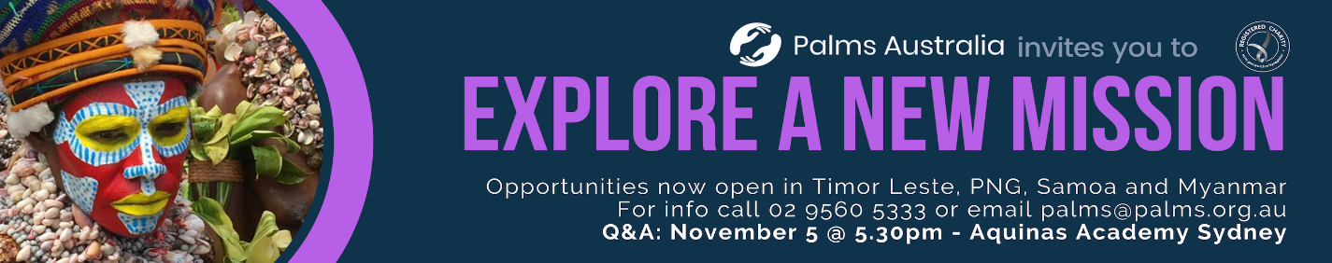
PLENARY COUNCIL 2020
The Plenary Council 2020 is a gathering of the Church in Australia to make decisions for the future.
How you can be involved:
- Talk with your parish priest about becoming a parish ambassador or to know more contact 9390 5100 or plenarycouncil@sydneycatholic.org
- Look out for a listening and dialogue session near you, or for more details contact 9390 5100, or plenarycouncil@sydneycatholic.org
- Make an individual and direct response to the national Plenary Council, via: http://plenarycouncil.catholic.org.au/resources/have-your-say/
- Share your response with the Archdiocese of Sydney, via: plenarycouncil@sydneycatholic.org
Want to know more? Watch the videos at: http://plenarycouncil.catholic.org.au/resources/watch/

BE AWAKE NATIONAL CATHOLIC MEN'S CONFERENCE
“Be Awake; stand firm in the faith; be courageous; be strong.” 1 Cor 16:13-16
“Where are you men of God? Are you AWAKE?” MenAlive and the Young Men of God Movement have united to host a life-changing event for the men of this nation from 19th to 21st October. The conference will bring the very best of MenAlive’s hugely successful MAX conference, and the unrivalled strength of the Young Men of God National Conference. There is nothing like the journey of growing in faith alongside your brothers. There will be great speakers, worship, prayer, sacraments, sports and brotherhood time. Be inspired, be transformed at this extraordinary event not to be missed! To register go to menalive.org.au or ymgmovement.org

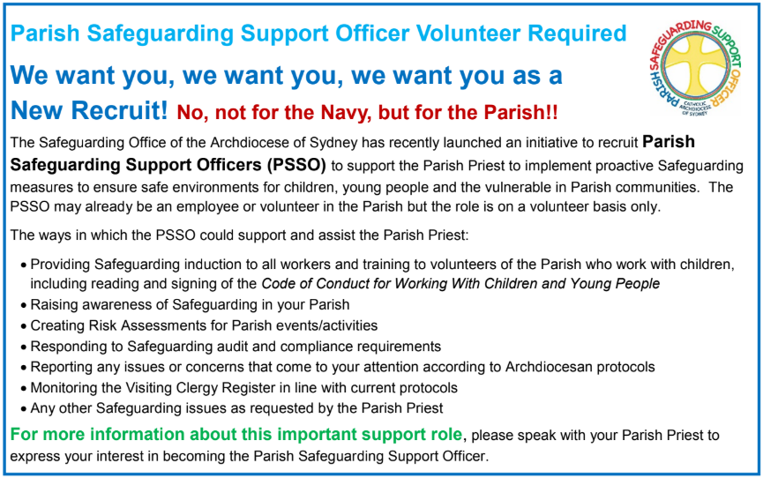

THE CATHOLIC ARCHDIOCESE OF SYDNEY SAFEGUARDING OFFICE
If you or a person close to you has been abused by someone working or ministering within the Archdiocese of Sydney we invite you to contact us. We will listen to you respectfully, offer support and discuss the options you have available to you. Please contact the Safeguarding and Ministerial Integrity Office on ph 02 9390 5812.

