SACRED HEART CHURCH
120 Carawatha Street Villawood
Telephone: (02) 9644-4026 Email: office@ihmsefton.org.au

Administrator: Fr Greg McGregor
Assistant Priest: Fr Thomas Alukka

SUNDAY MASS: Sunday: 9:00am
WEEKDAY MASSES: Wednesday and Friday – 8:00am
CONFESSIONS: On Request

Sunday, 21 Oct 2018: Twenty-Ninth Sunday in Ordinary Time - Year B

ENTRANCE ANTIPHON: To you I call; for you will surely heed me, O God; turn your ear to me; hear my words. Guard me as the apple of your eye; in the shadow of your wings protect me.

RESPONSORIAL PSALM: Lord, let your mercy be on us, as we place our trust in you.

GOSPEL ACCLAMATION: Alleluia, alleluia! The Son of Man came to serve and to give his life as a ransom for all. Alleluia!

COMMUNION ANTIPHON: Behold, the eyes of the Lord are on those who fear him, who hope in his merciful love, to rescue their souls from death, to keep them alive in famine.

VILLAWOOD MASSES:
Monday – 22nd October St Pope John Paul II. No Mass
Tuesday – 23rd October Sts John of Capistrano. No Mass
Wednesday – 24th October St Anthony Claret. Mass 8:00am
Thursday – 25th October 29th Week in Ordinary Time. No Mass
Friday – 26th October 29th Week in Ordinary Time. Mass 8:00am
Saturday – 27th October Saturday Mass of the Virgin Mary. No Mass
Sunday – 28th October 30th Sunday in Ordinary Time. Mass 9:00am

SEFTON MASSES:
Monday to Friday 9:15am
Saturday 9:15am, 5:30pm (Vigil)
Sunday 8:00am, 10:00am, 5:30pm

Total of both collections last Sunday: $357.15

ANNUAL LEAVE
Fr Thomas will be on annual leave until early November. We wish Fr Thomas a safe and relaxing break and thank Fr Gerry as he returns to Villawood to assist Fr Greg during this time.
Masses at Villawood will continue to be limited to Wednesday and Friday at 8:00am and Sunday at 9:00am. All parishioners are welcome to attend any of the masses at Sefton parish.
CATHOLIC WEEKLY - PULPIT POINTS 21st OCTOBER 2018
• Two new Saints: Martyred Archbishop and heroic Pope
• NEW LOOK Catholic Weekly - Win an iPad
• A passion for history: Author writes on Pius XII and the Jews
• Monica Doumit: Ruddock report - Straw Man
• Conservatives must unite: Mark Latham
• Movie review: First Man
Available in the foyer. $2 – all money goes to the poor.

FIRST HOLY COMMUNION
The Sacrament of First Holy Communion for the Sacred Heart primary children will be held this weekend on Sunday 21st October at 10:30am. We wish the students partaking in this Sacrament a wonderful and blessed day and congratulations. May you always stay as close to Jesus as you are on your First Holy Communion. Thank you to the teachers and staff at Sacred Heart Primary School for their dedication and support of the children to help make their day extra special.

CATHOLIC MISSIONS APPEAL
The Catholic Missions Appeal will be held this weekend of the 20th and 21st October, which happens to coincide with World Mission Day. Please give generously to support the people of Myanmar build their nation for future generations. Thank you.

ALL SOULS MASS – FRIDAY 2ND NOVEMBER 7:00PM AT SEFTON PARISH
All Parishioners are invited to Immaculate Heart of Mary, Sefton Parish on Friday 2nd November at 7:00pm to join in prayer for all deceased family members and friends, especially those who have died this past year. Everyone is invited to write the names of the deceased from the past 12 months in the Remembrance List in the Church foyer. Before Mass, names of the deceased will be called, and families and friends may light a candle in their honour.

CATHOLICCARE PRESENTATION
You don’t have to work out the home care system on your own. Staying independent in your own home is a priority for many Australian Seniors. CatholicCare’s Home Care Specialists can guide you through the complicated government systems. Join us and find out how to access in-home support and caring services.
When: Wednesday 7th November 10:00am (share a cuppa from 9:30am)
Where: Immaculate Heart of Mary Parish Sefton - Oblate Rooms (next to Church)
RSVP: Parish Office: 9644-4026
Who should attend? Seniors (even those who don’t need home care today); their friends and family; and community members who have regular contact with Seniors and may be able to help them get a start with organising home care.

CHECK OUT THE ARCHDIOCESE OF SYDNEY’S NEW WEBSITE
The Archdiocese has launched a fresh new-look website with all the latest news and information from across the archdiocese and the Church in Australia. From video to podcasts to links to social media where you can have your say on Catholic issues and share richer online content with friends and family, the new site also promotes major events across the archdiocese, regular updates from Archbishop Anthony Fisher as well as providing practical information for Catholics on Mass times, the sacraments and locating clergy and Catholic schools. Visit the new-look site at https://www.sydneycatholic.org/

OF LIFE AND LOVE – PRE-MARRIAGE COURSE
This excellent course for engaged couples gives particular emphasis to the spiritual and sacramental dimensions of marriage, while also paying due attention to the practical elements as well. It highlights the importance of God’s grace and human love in building a happy relationship, and it suggests ways in which married love can grow over the years. Topics include the beauty of Christian marriage, openness to life, family of origin, communication and the nuptial paradigm. An approved course for marriage preparation in the Catholic Church.
October 24 and 31, 7-10pm, Assisi Centre, Catholic Education Office, behind St. Joachim’s Parish, 3 Keating St. Lidcombe. More Info: Life, Marriage and Family Sydney Ph: 9307 8400 or E: LMFevents@sydneycatholic.org or to register: www.trybooking.com/book/event?eid=335146&

MASS FOR PREGNANT MOTHERS
Are you expecting a baby or know someone who is? You are warmly invited to attend the annual Mass for Pregnant Mothers to be celebrated by Most Rev Richard Umbers, Auxiliary Bishop of Sydney, at St Mary’s Cathedral on Sunday 18th of November at 10:30am. RSVP and enquiries can be directed to LMFevents@sydneycatholic.org or call 9307 8401.

MONTH OF PRAYER FOR MARRIAGE AND FAMILIES
Once again we are celebrating the Month of Prayer for Marriage and Families in October. Please go to this link to find resources you can use for the month: https://bit.ly/2yAvdB0
There are promotional posters and prayers to be used by families in the home and for prayers of intercession for the four Sundays in October for use during weekend Masses. For more info or assistance email Chris Gordon at the Life Office: christopher.gordon@sydneycatholic.org

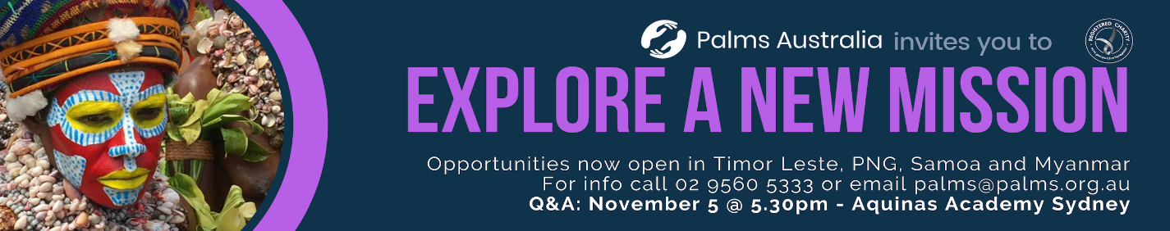

PLENARY COUNCIL 2020
The Plenary Council 2020 is a gathering of the Church in Australia to make decisions for the future.
How you can be involved:
- Talk with your parish priest about becoming a parish ambassador or to know more contact 9390 5100 or plenarycouncil@sydneycatholic.org
- Look out for a listening and dialogue session near you, or for more details contact 9390 5100, or plenarycouncil@sydneycatholic.org
- Make an individual and direct response to the national Plenary Council, via: http://plenarycouncil.catholic.org.au/resources/have-your-say/
- Share your response with the Archdiocese of Sydney, via: plenarycouncil@sydneycatholic.org
Want to know more? Watch the videos at: http://plenarycouncil.catholic.org.au/resources/watch/

CATHOLICCARE HOME CARE PACKAGES
CatholicCare provides services in your home to help you remain living independently. From occasional or short-term services to round-the-clock options, CatholicCare can help you decide on the services to meet your individual needs. For more information please contact the CCareline on 13 18 19.

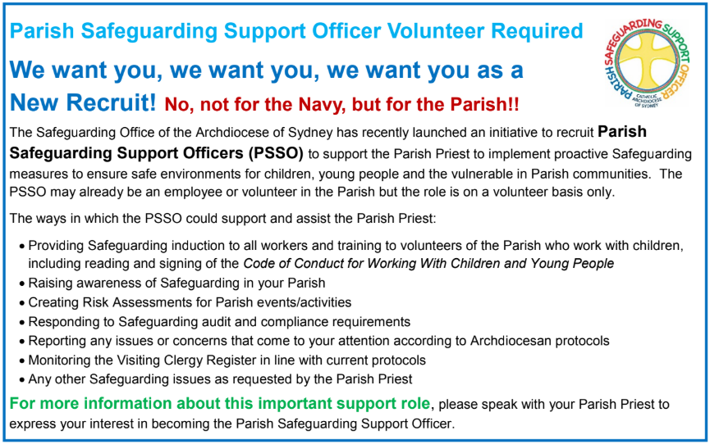

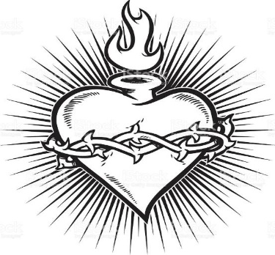

THE CATHOLIC ARCHDIOCESE OF SYDNEY SAFEGUARDING OFFICE
If you or a person close to you has been abused by someone working or ministering within the Archdiocese of Sydney we invite you to contact us. We will listen to you respectfully, offer support and discuss the options you have available to you. Please contact the Safeguarding and Ministerial Integrity Office on ph 02 9390 5812.

