SACRED HEART CHURCH
120 Carawatha Street Villawood
Telephone: (02) 9644-4026 Email: office@ihmsefton.org.au

Administrator: Fr Greg McGregor
Assistant Priest: Fr Thomas Alukka

SUNDAY MASS: Sunday: 9:00am
WEEKDAY MASSES: Wednesday and Friday – 8:00am
CONFESSIONS: On Request

Sunday, 28 Oct 2018: Thirtieth Sunday in Ordinary Time - Year B

ENTRANCE ANTIPHON: Let the hearts that seek the Lord rejoice; turn to the Lord and his strength; constantly seek his face.

RESPONSORIAL PSALM: The Lord has done great things for us; we are filled with joy. Lord, let your mercy be on us, as we place our trust in you.

GOSPEL ACCLAMATION: Alleluia, alleluia! Our Saviour Jesus Christ has done away with death, and brought us life through his gospel. Alleluia!

COMMUNION ANTIPHON: We will ring out our joy at your saving help and exult in the name of our God.

VILLAWOOD MASSES:
Monday – 29th October 30th Week in Ordinary Time. No Mass
Tuesday – 30th October 30th Week in Ordinary Time. No Mass
Wednesday – 31st October 30th Week in Ordinary Time. Mass 8:00am
Thursday – 1st November All Saints Day. No Mass
Friday – 2nd November All Souls Day. Mass 8:00am (All Souls Mass 7:00pm at Sefton Parish)
Saturday – 3rd November 30th Week in Ordinary Time. No Mass
Sunday – 4th November 31st Sunday in Ordinary Time. Mass 9:00am

SEFTON MASSES:
Monday to Friday 9:15am
Saturday 9:15am, 5:30pm (Vigil)
Sunday 8:00am, 10:00am, 5:30pm

Total of both collections last Sunday: $347.20 Catholic Missions Appeal: $75.00

ANNUAL LEAVE
Fr Thomas will be on annual leave until early November. We wish Fr Thomas a safe and relaxing break and thank Fr Gerry as he returns to Villawood to assist Fr Greg during this time.
Masses at Villawood will continue to be limited to Wednesday and Friday at 8:00am and Sunday at 9:00am. All parishioners are welcome to attend any of the masses at Sefton parish.

CATHOLIC WEEKLY - PULPIT POINTS 28TH OCTOBER 2018
• Blessings for the cute and cuddly
• NEW LOOK Catholic Weekly - Win an iPad - LAST CHANCE
• Students urge Synod to have courage
• Parish priest and...clan chief
• Grace flows abundantly at men’s gathering
• Movie review: Gosnell: The Trial of America’s Biggest
Serial Killer (GVN)
Available in the foyer. $2 – all money goes to the poor.

CATHOLIC MISSIONS APPEAL
Thank you for your generosity last weekend to support the people of Myanmar build their nation for future generations.

ALL SOULS MASS – FRIDAY 2ND NOVEMBER 7:00PM AT SEFTON PARISH
All Parishioners are invited to Immaculate Heart of Mary, Sefton Parish on Friday 2nd November at 7:00pm to join in prayer for all deceased family members and friends, especially those who have died this past year. Everyone is invited to write the names of the deceased from the past 12 months in the Remembrance List which is on the table at the back of the Church. Before Mass, names of the deceased will be called, and families and friends may light a candle in their honour.

CWF APPEAL
Next weekend, Sunday 4th November, your Parish will be asked to play an important role in supporting an important initiative of the Sydney Archdiocese: The Charitable Works Fund (CWF) Pastoral Appeal, our premier charity. Appeal envelopes will be provided for your use so please keep an eye out for them. Let us show our Christian solidarity for one another by sharing what we can with our neighbours. Thank you.

CATHOLICCARE PRESENTATION
You don’t have to work out the home care system on your own. Staying independent in your own home is a priority for many Australian Seniors. CatholicCare’s Home Care Specialists can guide you through the complicated government systems. Join us and find out how to access in-home support and caring services.
When: Wednesday 7th November 10:00am (share a cuppa from 9:30am)
Where: Immaculate Heart of Mary Parish Sefton - Oblate Rooms (next to Church)
RSVP: Parish Office: 9644-4026
Who should attend? Seniors (even those who don’t need home care today); their friends and family; and community members who have regular contact with Seniors and may be able to help them get a start with organising home care.

CHECK OUT THE ARCHDIOCESE OF SYDNEY’S NEW WEBSITE
The Archdiocese has launched a fresh new-look website with all the latest news and information from across the archdiocese and the Church in Australia. From video to podcasts to links to social media where you can have your say on Catholic issues and share richer online content with friends and family, the new site also promotes major events across the archdiocese, regular updates from Archbishop Anthony Fisher as well as providing practical information for Catholics on Mass times, the sacraments and locating clergy and Catholic schools. Visit the new-look site at https://www.sydneycatholic.org/

MASS FOR PREGNANT MOTHERS
Are you expecting a baby or know someone who is? You are warmly invited to attend the annual Mass for Pregnant Mothers to be celebrated by Most Rev Richard Umbers, Auxiliary Bishop of Sydney, at St Mary’s Cathedral on Sunday 18th of November at 10:30am. RSVP and enquiries can be directed to LMFevents@sydneycatholic.org or call 9307-8401.

MONTH OF PRAYER FOR MARRIAGE AND FAMILIES
We are celebrating the Month of Prayer for Marriage and Families in October. Please go to this link to find resources you can use for the month:
https://www.dropbox.com/sh/hne65hypizxp4mt/AABQlXVIFpuwNiiSjVROan6Ja?dl=0
There are promotional posters and prayers to be used by families in the home and for prayers of intercession for use during weekend Masses. For more info or assistance email Chris Gordon at the Life Office: christopher.gordon@sydneycatholic.org Like and join us on Facebook:
m.facebook.com/PrayForMarriage/?tsid=0.012018370298937597&source=result

PRAY FOR THE PLENARY COUNCIL
Across Australia, Catholics are gathering to pray, talk and listen to one another about our experiences of faith and the Church. Many parishes within the Archdiocese have commenced their journey towards the Plenary Council 2020, sharing and reflecting on the future of the Catholic church in Australia. Please continue to pray for the community of the Sydney Archdiocese that we will respond well to the call of the Holy Spirit, by engaging in the preparatory phase of the Plenary with open and humble hearts, listening to what the Spirit is saying to each one of us as we share our experiences of faith towards the preparation of the agenda of the Plenary Council. The Plenary Council Prayer: http://plenarycouncil.catholic.org.au/pray/ Want to know more on how to become involved? Please contact 9390 5147 or email plenarycouncil@sydneycatholic.org

SYDNEY CATHOLIC MEN’S MINISTRY NETWORK MEETING
Calling all Men! We all need the supportive brotherhood of other good men. Come and find out more about men’s ministry in Sydney archdiocese. Find out how you can start or join a local men’s group in your area with support from us. Hosted by Bishop Richard Umbers, hear from Tristan Ross, former lieutenant in the army on his experience of Catholic brotherhood. Ben Galea from Young Men of God will facilitate a discussion on growing new men’s groups. Friday night November 23, 6.30pm Mass, 7.30pm Dinner, 8.30pm Presentations. St. Paul of the Cross Parish, 532 New Canterbury Rd, Dulwich Hill. Register: www.trybooking.com/431767 More Info: christopher.gordon@sydneycatholic.org

CATHOLICCARE HOME CARE PACKAGES
CatholicCare provides services in your home to help you remain living independently. From occasional or short-term services to round-the-clock options, CatholicCare can help you decide on the services to meet your individual needs. For more information please contact the CCareline on 13 18 19.

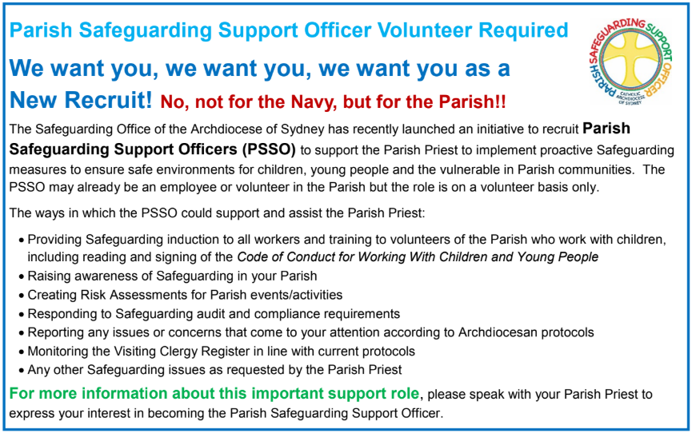

THE CATHOLIC ARCHDIOCESE OF SYDNEY SAFEGUARDING OFFICE
If you or a person close to you has been abused by someone working or ministering within the Archdiocese of Sydney we invite you to contact us. We will listen to you respectfully, offer support and discuss the options you have available to you. Please contact the Safeguarding and Ministerial Integrity Office on ph 02 9390 5812.

