SACRED HEART CHURCH

120 Carawatha Street Villawood

Telephone: (02) 9644-4026 Email: office@ihmsefton.org.au

Administrator: Fr Greg McGregor

Assistant Priest: Fr Thomas Alukka

SUNDAY MASS: Sunday: 9:00am

WEEKDAY MASSES: Wednesday and Friday – 8:00am

CONFESSIONS: On Request

**Sunday, 16 Sep 2018: Twenty-Fourth Sunday in Ordinary Time - Year B**

**ENTRANCE ANTIPHON**: Give peace, O Lord, to those who wait for you, that your prophets be found true. Hear the prayers of your servant, and of your people Israel.

**RESPONSORIAL PSALM**: I will walk in the presence of the Lord, in the land of the living.

**GOSPEL ACCLAMATION:** **Alleluia, alleluia!** My only glory is the cross of our Lord Jesus Christ, which crucifies the world to me and me to the world. **Alleluia!**

**COMMUNION ANTIPHON:** How precious is your mercy, O God! The children of men seek shelter in the shadow of your wings.

**VILLAWOOD MASSES:**

**Monday – 17th September** St Robert Bellarmine. No Mass

**Tuesday – 18th September** 24th Week in Ordinary Time. No Mass

**Wednesday – 19th September** St Januarius. Mass 8:00am

**Thursday – 20th September** Sts Andrew Kim Tae-gŏn, Paul Chŏng Ha-sang. No Mass

**Friday – 21st September** St Matthew. Mass 8:00am

**Saturday – 22nd September** Mass of the Virgin Mary. No Mass

**Sunday – 23rd September** 25th Sunday in Ordinary Time. Mass 9:00am

**SEFTON MASSES:**

**Monday to Friday** 9:15am

**Saturday** 9:15am, 5:30pm (Vigil)

**Sunday** 8:00am, 10:00am, 5:30pm

Total of both collections last Sunday: $487.15

**ANNUAL LEAVE FOR FR GREG**

Fr Greg will be away **until 10th October** on annual leave, taking a well-earned break. We welcome Fr Tom Stevens (Liverpool Parish) who will be helping out during this time. Masses at Villawood will be limited to Wednesday and Friday at 8:00am and Sunday at 9:00am. All parishioners are welcome to attend any of the masses at Sefton parish.

**CATHOLIC WEEKLY - PULPIT POINTS 16TH SEPTEMBER 2018**

• Victorian confession fight looms

• The reunion you have when you’re not having a reunion

• $10,000 poetry prize winner

• Archbishop awards student excellence

• Movie review: Kin

• Fight for the church: Editorial

*Available in the foyer. $2 – all money goes to the poor.*

**SACRAMENTAL DATES FOR 2018**

The Sacrament of First Holy Communion for the Sacred Heart parish will be held on **Sunday 21st October at 10:30am.** Applications for this Sacrament are now closed.

**BAPTISM**



Please pray for CHARLEE WRIGHT as we welcome her into our parish community

through the sacrament of baptism on Sunday, 16th September 2018. Let us pray

also for her parents and godparents, that the Lord may help them in raising

Charlee in the practice of the faith.

**WORLD ROSARY**

Countries around the world are joining to hold Rosary Rallies across the world on **7th October**, the Feast of Our Lady of the Rosary. Together we are calling upon God, through the powerful intercession of Our Lady of the Rosary. Each nation has been asked to pray for its own intentions on the day. To sign up for the email feed to <http://holyleagueofnations.com> Australian intentions for the world rosary will be *family, rekindling of faith and continued Godly protection.* We have been doing regular novena prayers to St Joseph, Eileen O Conner etc via Facebook, a new one is posted every couple of weeks. The link is[**https://www.facebook.com/OZROSARY53/**](https://www.facebook.com/OZROSARY53/) **The website to register your involvement for the world rosary is holyleagueofnations.com. Jane, OzRosary, 0476 535 59**

**To Register in Australia: https://ozrosary.wixsite.com/ozrosary53/contact-us-and-participate**

**INVITATION TO SEFTON PARISH RETREAT**

All Villawood parishioners are invited to the Annual Sefton Parish Retreat which is to be held from **Friday, 19th October to Sunday, 21st October at Mt Carmel Retreat Centre in Varroville**. The cost of the retreat is **$200 per person**. **For more information**, please contact Kath on 9644-8163 or the Parish Office on 9644-4026. If you wish to attend, please complete and return the registration form (together with $30 deposit) which will be available in the church foyer.

**ST VINCENT DE PAUL VOLUNTEERS NEEDED**

Every **Thursday, 6-8pm,** a group of St Vincent de Paul volunteers meet at the **Parish Centre at IHM Sefton** to go out into the community and assist those in need at their homes. This group has been active in the local area for over 40 years and are currently seeking new members to help out with this great initiative. Pairs of volunteers conduct home visits as prescribed by the regional office of St Vincent de Paul. If you wish to join the band of amazing volunteers, please register your interest with **Geoff Barrett on 9897-3509**. Thank you for considering this worthwhile mission.

**PLENARY COUNCIL 2020**

The Plenary Council 2020 is a gathering of the Church in Australia to make decisions for the future.

How you can be involved:

* Talk with your parish priest about becoming a parish ambassador or to know more contact 9390 5100 or plenarycouncil@sydneycatholic.org
* Look out for a listening and dialogue session near you, or for more details contact 9390 5100, or plenarycouncil@sydneycatholic.org
* Make an individual and direct response to the national Plenary Council, via: http://plenarycouncil.catholic.org.au/resources/have-your-say/
* Share your response with the Archdiocese of Sydney, via: plenarycouncil@sydneycatholic.org

Want to know more? Watch the videos at: http://plenarycouncil.catholic.org.au/resources/watch/

**FEAST DAY OF SAINT PADRE PIO**

St Padre Pio was an Italian priest who was canonised as a Saint on June 16, 2002 and whose feast day is September 23. This September on St Padre Pio’s feast day, the St. Padre Pio Parish in Glenmore Park will be hosting a feast to celebrate the 100th Anniversary of his stigmata and 50th Anniversary of his death. A procession will be followed by a mass and celebration as well as there being a relic of St Padre Pio available for veneration and blessing. All parishioners are invited to attend. Please see the poster or business cards in the foyer for further information.

**MURDER IN THE CATHEDRAL**

Artes Christi presents T. S. Eliot’s play of St Thomas Becket, directed by internationally acclaimed actor and writer, Donald Macdonald. The play is being staged to coincide with the Canonisation of Archbishop Oscar Romero who was the first Archbishop since Becket to be martyred at the altar. The play is also supporting persecuted people today via *Aid to the Church in Need*. Shows from the 27th September to the 14th October at 1880 Hall, St Peter’s Surry Hills. Group tickets from $30. Bookings are essential via [www.theword.org.au](http://www.theword.org.au) or 1800 101 201.

**SOCIAL JUSTICE SUNDAY – 30TH SEPTEMBER**

We celebrate Social Justice Sunday on 30th September. This year, the Australian Bishops’ Social Justice Statement is titled: ‘A Place to Call Home: Making a home for everyone in our land’. The statement challenges us all to confront Australia’s growing rate of homelessness and unaffordable housing. For further details, visit the [www.socialjustice.catholic.org.au](http://www.socialjustice.catholic.org.au) or call 8306 3499.

**TEACHING DAY – SATURDAY 22nd SEPTEMBER**

St Joseph’s Prayer Group at Enfield is hosting a Teaching Day on Saturday 22nd September. The day costs $15 and will be hosted at St Joseph’s Catholic Church, Enfield. Please bring your bible with you and a dish for our communal lunch. Any questions, contact Rose on 9642 2359/0412 115 961.

**FLAT FOR RENT**

A one bedroom granny flat has become available for rent at $180/week, located near Birrong station. The flat is not suitable for a family however would be ideal for an elderly couple or single parent. If interested, contact **Lynh Nguyen on 0415 204 230.**

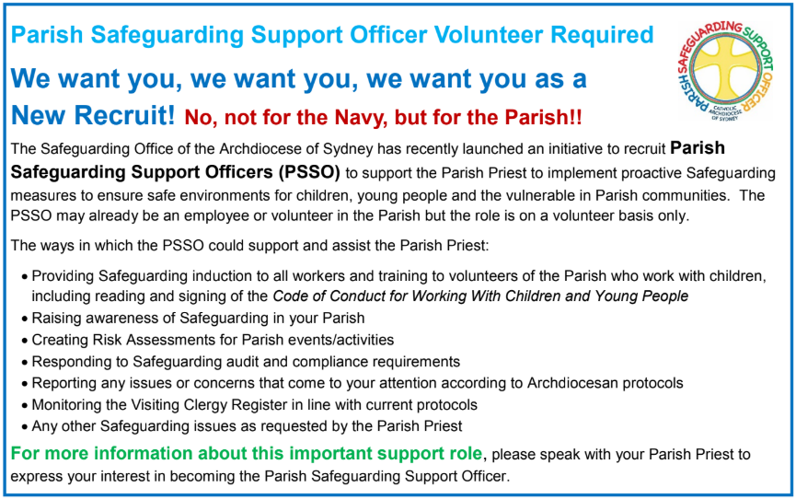



**THE CATHOLIC ARCHDIOCESE OF SYDNEY SAFEGUARDING OFFICE**

If you or a person close to you has been abused by someone working or ministering within the Archdiocese of Sydney we invite you to contact us. We will listen to you respectfully, offer support and discuss the options you have available to you. Please contact the Safeguarding and Ministerial Integrity Office on **ph 02 9390 5812**.