SACRED HEART CHURCH
120 Carawatha Street Villawood
Telephone: (02) 9644-4026 Email: office@ihmsefton.org.au

Administrator: Fr Greg McGregor
Assistant Priest: Fr Thomas Alukka

SUNDAY MASS: Sunday: 9:00am
WEEKDAY MASSES: Tuesday to Friday – 8:00am
CONFESSIONS: On Request

Sunday, 2nd September 2018: Twenty-Second Sunday in Ordinary Time Year B

ENTRANCE ANTIPHON: Have mercy on me, O Lord, for I cry to you all the day long. O Lord, you are good and forgiving, full of mercy to all who call to you.

RESPONSORIAL PSALM: The just will live in the presence of the Lord.

GOSPEL ACCLAMATION: Alleluia, alleluia! The Father gave us birth by his message of truth, that we might be as the first fruits of his creation. Alleluia!

COMMUNION ANTIPHON: How great is the goodness, Lord, that you keep for those who fear you.

VILLAWOOD MASSES:
Monday – 3rd September St Gregory the Great. No Mass
Tuesday – 4th September 22nd Week in Ordinary Time. Mass 8:00am
Wednesday – 5th September 22nd Week in Ordinary Time. Mass 8:00am
Thursday – 6th September 22nd Week in Ordinary Time. Mass 8:00am
Friday – 7th September Spring Ember Day. Mass 8:00am
Saturday – 8th September The Nativity of the Blessed Virgin Mary. No Mass
Sunday – 9th September 23rd Sunday in Ordinary Time. Mass 9:00am

SEFTON MASSES:
Monday to Friday 9:15am
Saturday 9:15am, 5:30pm (Vigil)
Sunday 8:00am, 10:00am, 5:30pm

Total of both collections last Sunday: $322.25 Priest Retirement Fund: $100 CWF: $10

NATIONAL CHILD PROTECTION WEEK
NCPW commences on 2nd September to the final day being Sunday 9th September. Please find “Someone will Listen to You” Postcards at the back of the Church which have been developed for children and young people with the assistance of children and young people from our parishes in the Archdiocese.
CATHOLIC WEEKLY - PULPIT POINTS 2nd SEPTEMBER 2018
• Catholics gather with Francis in Dublin
• The awkward blessing of natural family planning
• Taste & believe - The monks who brew beer
• The joy of religious life
• Movie review: Christopher Robin
• Families celebrate with Francis
Available in the foyer. $2 – all money goes to the poor.

ANNUAL LEAVE FOR FR GREG
Fr Greg will be away from 10th September until 10th October on annual leave, taking a well earned break. Whilst he is away, masses at Villawood will be limited to Wednesday and Friday at 8:00am and Sunday at 9:00am. All parishioners are welcome to attend any of the masses at Sefton parish. We wish Fr Greg a blessed, safe and happy holiday!

SACRAMENTAL DATES FOR 2018
The Sacrament of First Holy Communion for the Sacred Heart parish will be held on Sunday 21st October at 10:30am. Please see the office of Sacred Heart Catholic Primary School to enrol for this sacrament prior to Friday 7th September. Thank you.

PRIESTS’ RETIREMENT FUND PASTORAL APPEAL
Once again, we ask of your generosity regarding the Priests’ Retirement Fund due to the significant assistance it provides to retired priests. Archbishop Anthony is committed to supporting priests when they move from a full-time ministry so that they are not disadvantaged with respect to housing, living expenses, health care and transport to name a few. However, in order to provide this support, we need to increase the income to the Retirement Fund. The Fund currently runs at a significant deficit despite the archdiocese contributing one dollar for every dollar raised by the annual appeal. Thus, we ask for any donation you are able to give in order to provide assistance to our retired priests who have so generously given their lives to our community and faith. This appeal will occur on this weekend of the 1st and 2nd of September and we are extremely grateful for any donation you are able to contribute, be it large or small.

ST VINCENT DE PAUL VOLUNTEERS NEEDED
Every Thursday, 6-8pm, a group of St Vincent de Paul volunteers meet at the Parish Centre at IHM Sefton to go out into the community and assist those in need at their homes. This group has been active in the local area for over 40 years and are currently seeking new members to help out with this great initiative. Pairs of volunteers conduct home visits as prescribed by the regional office of St Vincent de Paul. If you wish to join the band of amazing volunteers, please register your interest with Geoff Barrett on 9897-3509. Thank you for considering this worthwhile mission.

PLENARY COUNCIL
Why not be involved? The 2020 Plenary Council is a gathering of the Church in Australia to make decisions for the future. Your voice is important. You are invited to contribute to the Plenary Council agenda, by sharing your experience of faith and of the Church. To be involved, visit http://plenarycouncil.catholic.org.au/
Become an Ambassador, facilitating listening and dialogue groups in your parish. If you want to know more, please speak with your Parish Priest, contact 9390 5100 or email plenarycouncil@sydneycatholic.org

SEPTEMBER HEALING MASS
All parishioners are invited to attend the September Healing Mass at St Joseph’s Catholic Church 126 Liverpool Rd Enfield on Friday 7th September. If you have any queries, feel free to contact Rose on 9642-2359 or 0412 115 961. Thank you.

INVITATION TO SEFTON PARISH RETREAT
All Villawood parishioners are invited to the Annual Sefton Parish Retreat which is to be held from Friday, 19th October to Sunday, 21st October at Mt Carmel Retreat Centrre in Varroville. The cost of the retreat is $200 per person. For more information, please contact Kath on 9644-8163 or the Parish Office on 9644-4026. If you wish to attend, please complete and return the registration form (together with $30 deposit) which will be available in the church foyer.

OLMC PARRAMATTA OPEN MORNING TOUR
Our Lady of Mercy College Parramatta warmly invites you to attend our Open Morning Tour on Wednesday, 5 September 2018. Tour the College and discover how a Mercy Education empowers girls to expand beyond what they know they can be and enjoy a ‘comfortable cup of tea’ with the College Leadership Team. The College is now enrolling for 2020. Visit www.olmc.nsw.edu.au to reserve your place or contact the Registrar 8838 1222 to discuss how your daughter can become a Mercy Girl.

SOCIAL JUSTICE SUNDAY – 30TH SEPTEMBER
We celebrate Social Justice Sunday on 30th September. This year, the Australian Bishops’ Social Justice Statement is titled: ‘A Place to Call Home: Making a home for everyone in our land’. The statement challenges us all to confront Australia’s growing rate of homelessness and unaffordable housing. For further details, visit the www.socialjustice.catholic.org.au or call 8306 3499.

UPCOMING RETREATS
- Praying in the Cloud – 8th September
- Pilgrimage Walk 2018 – 23rd September
- More Alive, More Human – 28th-30th September
- Sefton Parish Retreat – 19th-21st October
Please see flyers at the back of the church if interested, or contact the parish office if removed.

ST ALOYSIUS’ COLLEGE OPEN DAY
St Aloysius’ College invites you to attend our biennial Open Day on Sunday 9th September 2018. We will demonstrate how St Aloysius’ educates young men of conscience, competence, compassion and commitment. This is an opportunity for you to tour our facilities and to meet our teachers and students, providing an insight into teaching and learning at St Aloysius’. A range of co-curricular activities including Sports, Drama, Music and Cadets will be on display, showcasing the well-rounded school experience the College offers. Staff and students will also be available to share with you the religious and spiritual life of the College, how we care for each student, and partner with their parents as they become “Men for Others”.
Junior School (Years 3 to 6): 9.30am - 12.00pm at 29 Burton Street, Milsons Point
Senior School (Years 7 to 12): 10.30am - 1.00pm at 47 Upper Pitt Street, Milsons Point
Bookings are not required. For further information, please visit the College website www.staloysius.nsw.edu.au or contact the Registrar on 02 9936 5535 or registrar@staloysius.nsw.edu.au
Please note that parking in the area is limited. The College encourages all guests to use public transport.

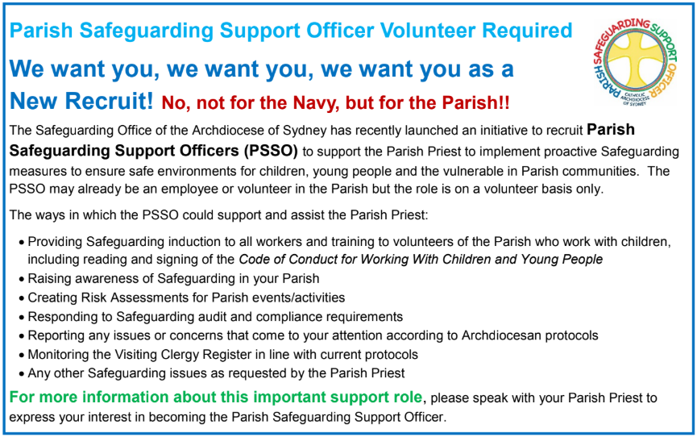

THE CATHOLIC ARCHDIOCESE OF SYDNEY SAFEGUARDING OFFICE
If you or a person close to you has been abused by someone working or ministering within the Archdiocese of Sydney we invite you to contact us. We will listen to you respectfully, offer support and discuss the options you have available to you. Please contact the Safeguarding and Ministerial Integrity Office on ph 02 9390 5812.

