SACRED HEART CHURCH
120 Carawatha Street Villawood
Telephone: (02) 9644-4026 Email: office@ihmsefton.org.au

Administrator: Fr Greg McGregor
Assistant Priest: Fr Thomas Alukka

SUNDAY MASS: Sunday: 9:00am
WEEKDAY MASSES: Wednesday and Friday – 8:00am
CONFESSIONS: On Request

Sunday, 30 Sep 2018: Twenty-sixth Sunday in Ordinary Time - Year B

ENTRANCE ANTIPHON: All that you have done to us, O Lord, you have done with true judgement, for we have sinned against you and not obeyed your commandments. But give glory to your name and deal with us according to the bounty of your mercy.

RESPONSORIAL PSALM: The precepts of the Lord give joy to the heart.

GOSPEL ACCLAMATION: Alleluia, alleluia! Your word, O Lord, is truth: make us holy in the truth. Alleluia!

COMMUNION ANTIPHON: Remember your word to your servant, O Lord, by which you have given me hope. This is my comfort when I am brought low.

VILLAWOOD MASSES:
Monday – 1st October St Therese of the Child Jesus. No Mass
Tuesday – 2nd October The Holy Guardian Angels. No Mass
Wednesday – 3rd October 26th Week in Ordinary Time. Mass 8:00am
Thursday – 4th October St Francis of Assisi. No Mass
Friday – 5th October 26th Week in Ordinary Time. Mass 8:00am
Saturday – 6th October 26th Week in Ordinary Time. No Mass
Sunday – 7th October 27th Sunday in Ordinary Time. Mass 9:00am

SEFTON MASSES:
Monday to Friday 9:15am
Saturday 9:15am, 5:30pm (Vigil)
Sunday 8:00am, 10:00am, 5:30pm

Total of both collections last Sunday: $354.20

ANNUAL LEAVE FOR FR GREG
Fr Greg will be away until 10th October on annual leave, taking a well-earned break. We welcome Fr Tom Stevens (Liverpool Parish) who will be helping out during this time. Masses at Villawood will be limited to Wednesday and Friday at 8:00am and Sunday at 9:00am. All parishioners are welcome to attend any of the masses at Sefton parish.

CATHOLIC WEEKLY - PULPIT POINTS 30TH SEPTEMBER 2018
• Fleet blessed amid a sea of people
• NEW LOOK Catholic Weekly: Win an iPad
• Schoolboy league: Fairfield Pats crowned 2018 champions
• Ignite coming to Sydney
• Movie review: Unbroken
Available in the foyer. $2 – all money goes to the poor.

SACRAMENTAL DATES FOR 2018
The Sacrament of First Holy Communion for the Sacred Heart parish will be held on Sunday 21st October at 10:30am.

CHECK OUT THE ARCHDIOCESE OF SYDNEY’S NEW WEBSITE
The Archdiocese has launched a fresh new-look website with all the latest news and information from across the archdiocese and the Church in Australia. From video to podcasts to links to social media where you can have your say on Catholic issues and share richer online content with friends and family, the new site also promotes major events across the archdiocese, regular updates from Archbishop Anthony Fisher as well as providing practical information for Catholics on Mass times, the sacraments and locating clergy and Catholic schools. Visit the new-look site at https://www.sydneycatholic.org/

POSITIONS VACANT
Youth Coordinator, Our Lady of Fatima Parish Kingsgrove. Part-time position, 20 hours per week. For further information please contact Anthony Spata on 0402 210 055. Applications close Friday, 5 October 2018.

SOCIAL JUSTICE SUNDAY – 30TH SEPTEMBER
We celebrate Social Justice Sunday on 30th September. This year, the Australian Bishops’ Social Justice Statement is titled: ‘A Place to Call Home: Making a home for everyone in our land’. The statement challenges us all to confront Australia’s growing rate of homelessness and unaffordable housing. For further details, visit www.socialjustice.catholic.org.au or call 8306 3499.

WORLD ROSARY
Countries around the world are joining to hold Rosary Rallies across the world on 7th October, the Feast of Our Lady of the Rosary. Together we are calling upon God, through the powerful intercession of Our Lady of the Rosary. Each nation has been asked to pray for its own intentions on the day. Australian intentions for the world rosary will be family, rekindling of faith and continued Godly protection. To sign up for the email feed to http://holyleagueofnations.com
To Register in Australia: https://ozrosary.wixsite.com/ozrosary53/contact-us-and-participate

DEVOTIONS TO HONOUR OUR LADY OF LOURDES
Mass and Blessing of the Sick will be held at Our Lady of Lourdes Grotto, Earlwood, on Sunday, 14th October 2018 (behind Our Lady of Lourdes Church, Earlwood), entrance via St. James Avenue, Earlwood, commencing with recitation of the Rosary at 2:30 p.m. followed by Mass and the Blessing of the Sick at 3:00 p.m. The Principal celebrant will be Bishop Peter Ingham, Emeritus Bishop of Wollongong. Some parking for disabled people is available in the school grounds and general parking in the nearby council car park.

INVITATION TO SEFTON PARISH RETREAT
All Villawood parishioners are invited to the Annual Sefton Parish Retreat which is to be held from Friday, 19th October to Sunday, 21st October at Mt Carmel Retreat Centre in Varroville. The cost of the retreat is $200 per person. For more information, please contact Kath on 9644-8163 or the Parish Office on 9644-4026. If you wish to attend, please complete and return the registration form (together with $30 deposit) which will be available in the church foyer.

PLENARY COUNCIL 2020
The Plenary Council 2020 is a gathering of the Church in Australia to make decisions for the future.
How you can be involved:
- Talk with your parish priest about becoming a parish ambassador or to know more contact 9390 5100 or plenarycouncil@sydneycatholic.org
- Look out for a listening and dialogue session near you, or for more details contact 9390 5100, or plenarycouncil@sydneycatholic.org
- Make an individual and direct response to the national Plenary Council, via: http://plenarycouncil.catholic.org.au/resources/have-your-say/
- Share your response with the Archdiocese of Sydney, via: plenarycouncil@sydneycatholic.org
Want to know more? Watch the videos at: http://plenarycouncil.catholic.org.au/resources/watch/

NCC SYDNEY ANNUAL FUNDRAISING DINNER 2018
Join us as we celebrate the year’s achievements and hear from guest speaker, Mark Latham, on Friday, 12th October 2018 at 7:00pm. The function will be held at The Epping Club, 45-47 Rawson Street, Epping, NSW 2121. Tickets can be booked online at www.trybooking.com/xzxz

MURDER IN THE CATHEDRAL
Artes Christi presents T. S. Eliot’s play of St Thomas Becket, directed by internationally acclaimed actor and writer, Donald Macdonald. The play is being staged to coincide with the Canonisation of Archbishop Oscar Romero who was the first Archbishop since Becket to be martyred at the altar. The play is also supporting persecuted people today via Aid to the Church in Need. Shows from the 27th September to the 14th October at 1880 Hall, St Peter’s Surry Hills. Group tickets from $30. Bookings are essential via www.theword.org.au or 1800 101 201.

BILLINGS TEACHER TRAINING COURSE
Novotel, Brisbane - Friday 9th November & Saturday 10th November, 2018
A Program for Health Professionals and others interested in Woman’s Health.
This course will give participants sufficient knowledge to offer women and couples an overview of the Billings Ovulation Method® of natural fertility regulation to assist them to achieve pregnancy, avoid pregnancy naturally and monitor reproductive health. Further training is offered for those wishing to go ahead to Accreditation. http://www.billings.life/en/for-health-professionals-2/seminars-download-3/item/358-bom-ttp-brisbane.html
Please call Billings LIFE on 1800 335 860 or check out our website and shop.
Website: www.billings.life Shop: https://billings.ecwid.com/
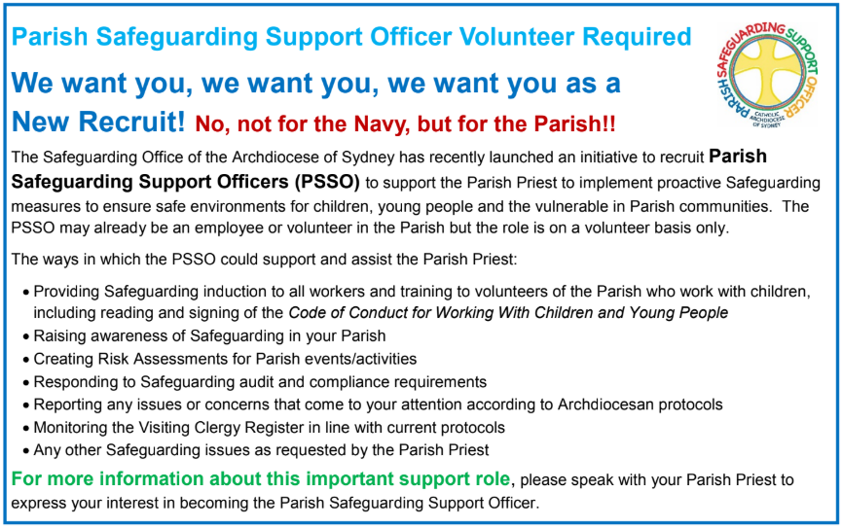

CATHOLICCARE HOME CARE PACKAGES
CatholicCare provides services in your home to help you remain living independently. From occasional or short-term services to round-the-clock options, CatholicCare can help you decide on the services to meet your individual needs. For more information please contact the CCareline on 13 18 19.

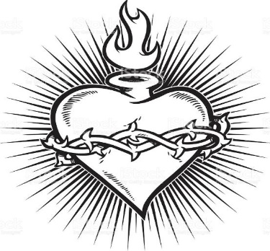

THE CATHOLIC ARCHDIOCESE OF SYDNEY SAFEGUARDING OFFICE
If you or a person close to you has been abused by someone working or ministering within the Archdiocese of Sydney we invite you to contact us. We will listen to you respectfully, offer support and discuss the options you have available to you. Please contact the Safeguarding and Ministerial Integrity Office on ph 02 9390 5812.

