SACRED HEART CHURCH
120 Carawatha Street Villawood
Telephone: (02) 9644-4026 Email: office@ihmsefton.org.au

Administrator: Fr Greg McGregor
Assistant Priest: Fr Thomas Alukka

SUNDAY MASS: Sunday: 9:00am
WEEKDAY MASSES: Tuesday to Friday – 8:00am
CONFESSIONS: On Request

Sunday, 19th August 2018: Twentieth Sunday in Ordinary Time Year B

ENTRANCE ANTIPHON: Turn your eyes, O God, our shield; and look on the face of your anointed one; one day within your courts is better than a thousand elsewhere.

RESPONSORIAL PSALM: Taste and see the goodness of the Lord.

GOSPEL ACCLAMATION: Alleluia, alleluia! All who eat my flesh and drink my blood live in me and I in them, says the Lord. Alleluia!

COMMUNION ANTIPHON: With the Lord there is mercy; in him is plentiful redemption.

VILLAWOOD MASSES:
Monday – 20th August St Bernard. No Mass
Tuesday – 21st August St Pius X. Mass 8:00am
Wednesday – 22nd August The Queenship of the Blessed Virgin Mary. Mass 8:00am
Thursday – 23rd August St Rose of Lima. Mass 8:00am
Friday – 24th August St Bartholomew. Mass 8:00am
Saturday - 25th August St Louis & St Joseph Calasanz. No Mass
Sunday - 26th August 21st Sunday in Ordinary Time. Mass 9:00am

SEFTON MASSES:
Monday to Friday 9:15am
Saturday 9:15am, 5:30pm (Vigil)
Sunday 8:00am, 10:00am, 5:30pm

Total of both collections last Sunday: $335.60 CWF: $20

ANNUAL LEAVE FOR FR GREG
Fr Greg will be away from 10th September until 10th October on annual leave, taking a well earned break. Whilst he is away, masses at Villawood will be limited to Wednesday and Friday at 8:00am and Sunday at 9:00am. All parishioners are welcome to attend any of the masses at Sefton parish. We wish Fr Greg a blessed, safe and happy holiday!

CATHOLIC WEEKLY - PULPIT POINTS 19TH AUGUST 2018
• New labourer for the vineyard - Matt Meagher ordination
• Peakhurst parish: Mighty drought fundraiser
• Legal tragedy: Academics speak out on euthanasia
• A light in darkness
• Movie review: The Darkest Minds
• Universities and Colleges Open Days liftout
Available in the foyer. $2 – all money goes to the poor.

SACRED HEART PRIMARY SCHOOL YEAR 3 RECONCILIATION & CLASS VISITS
On Thursday, 23rd August, Year 3 will be participating in reconciliation at 10:30am which will be followed by the parish priest visiting the classes and talking to the students. We wish Year 3 a spiritual and informative day! Next week, Year 2 students will have this great opportunity.

SACRAMENTAL DATES FOR 2018
We would like to extend our congratulations from the parishioners at Sacred Heart Parish to all those children who celebrated the sacrament of Reconciliation for the first time on Saturday 18th August at 10:30am. May God bless and guide them into the future.
The Sacrament of First Holy Communion for the Sacred Heart parish will be held on Sunday 21st October at 10:30am. Please see the office of Sacred Heart Catholic Primary School to enrol for this sacrament.

ST VINCENT DE PAUL VOLUNTEERS NEEDED
Every Thursday, 6-8pm, a group of St Vincent de Paul volunteers meet at the Parish Centre at IHM Sefton to go out into the community and assist those in need at their homes. This group has been active in the local area for over 40 years and are currently seeking new members to help out with this great initiative. Pairs of volunteers conduct home visits as prescribed by the regional office of St Vincent de Paul. If you wish to join the band of amazing volunteers, please register your interest with Geoff Barrett on 9897-3509. Thank you for considering this worthwhile mission.

PLENARY COUNCIL
Why not be involved? The 2020 Plenary Council is a gathering of the Church in Australia to make decisions for the future. Your voice is important. You are invited to contribute to the Plenary Council agenda, by sharing your experience of faith and of the Church. To be involved, visit http://plenarycouncil.catholic.org.au/
Become an Ambassador, facilitating listening and dialogue groups in your parish. If you want to know more, please speak with your Parish Priest, contact 9390 5100 or email plenarycouncil@sydneycatholic.org

MEMORIAL MASS FOR THE UNBORN
Most Rev Anthony Randazzo, Auxiliary Bishop of Sydney, will offer the annual Memorial Mass for the Unborn on Wednesday 29th August at 7:00pm at St Mary’s Cathedral. The Mass will be offered in commemoration of the unborn children lost to abortion and in solidarity with the mothers and fathers who grieve this profound loss. During the Mass, 74 candles will be brought forward in remembrance of the 74 lives lost to abortion each day in NSW. All are invited to attend. Enquiries: Life, Marriage and Family Centre: 9307 8400 or LMFevents@sydneycatholic.org

CATHOLICCARE SYDNEY
A representative from Catholic Care will be conducting a presentation for parishioners interested in learning about their entitlements and gaining assistance in relation to services available for in-home care.
When: Wednesday 22 August
Time: 10.00am start, so arrive from 9.30am
Where: St Mary Queen of Heaven church, 15 Georges Crescent, Georges Hall
Presenter: Deborah Absalom, Catholic Care
RSVP or Enquiries: Veronica 0407 231 262
Following the presentation there will be time for questions, discussion. Morning tea will be provided afterwards. If any parishioners are interested, you are most welcome to come along.

INVITATION TO SEFTON PARISH RETREAT
Is Jesus calling you today to come to Him and rest your weary spirit in Him?
That’s how much God loves you! He is compassionate and understanding and wants your undivided attention and love. So, please join us this year at our Annual Retreat Weekend and experience this wonderful love of God. As we free ourselves from the daily routines of life, the demands of family and work, we will be more able to present to God an open and receiving heart, a listening ear and eyes willing to see the wonder and reality of His presence all around us.
Why do people keep coming back year after year (some over 20 years)?
At these Retreats, many of us have found healing and compassionate understanding, deepening of faith, strength for life’s journey, a sense of belonging and a hunger to experience a deeper relationship with God and hear His voice more clearly than in the midst of the noise of daily life. It is a time to allow God to renew us physically and spiritually as we meditate on scriptures, sit and contemplate the beauty of His creation, pray and reflect and listen from the heart to what God may be saying to us. It is a time of many blessings. It is also a time of community, laughter and friendship as we gather on Saturday evening for a get-together, have some nibbles and drinks and enjoy each other’s company. This year, the program includes religious sessions each day with Fr James Jeyachandran OMI, who will be flying across from Perth to be our guest speaker. There will be quiet time for prayer and reflection, or walks in the grounds savouring the stillness and beauty of God’s creation. The Carmelite Community also welcomes us to join them in the Eucharist, Liturgy of the hours and silent prayer. The Sacrament of Reconciliation will also be available.
Date of Retreat - Arrive from 3.00pm with dinner commencing from 6.00 pm on Friday, 19th October and ending after lunch on Sunday, 21st October 2018.
Cost of Retreat - $200 per person. Single and double rooms are available, the double rooms have either 2 single beds or a double bed.
Location of Retreat - Mt Carmel Retreat Centre, 247 St Andrews Road Varroville. The location of the Centre is approximately 45 min. from Sefton and is set in beautiful semi-rural and peaceful surroundings.
Amenities - All rooms feature en-suites with many rooms having direct, level access to the prayer
room, dining room, conference room and chapel. All at the Centre are friendly and hospitable; the
food is plentiful, home-made and appetising and the amenities are comfortable and clean.
For more information, please contact Kath on 9644-8163 or the Parish Office on 9644-4026. Please complete and return the registration form (together with $30 deposit) which will be available in the church foyer from next weekend.

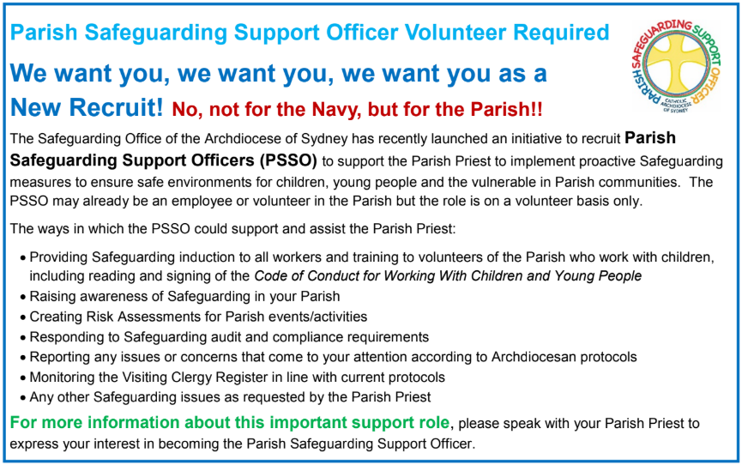

FLAT FOR RENT
A one bedroom granny flat has become available for rent at $180/week, located near Birrong station. The flat is not suitable for a family however would be ideal for an elderly couple or single parent. If interested, contact Lynh Nguyen on 0415 204 230.

THE CATHOLIC ARCHDIOCESE OF SYDNEY SAFEGUARDING OFFICE
If you or a person close to you has been abused by someone working or ministering within the Archdiocese of Sydney we invite you to contact us. We will listen to you respectfully, offer support and discuss the options you have available to you. Please contact the Safeguarding and Ministerial Integrity Office on ph 02 9390 5812.

ST ALOYSIUS’ COLLEGE OPEN DAY
St Aloysius’ College invites you to attend our biennial Open Day on Sunday 9th September 2018. We will demonstrate how St Aloysius’ educates young men of conscience, competence, compassion and commitment.
This is an opportunity for you to tour our facilities and to meet our teachers and students, providing an insight into teaching and learning at St Aloysius’. A range of co-curricular activities including Sports, Drama, Music and Cadets will be on display, showcasing the well-rounded school experience the College offers. Staff and students will also be available to share with you the religious and spiritual life of the College, how we care for each student, and partner with their parents as they become “Men for Others”.
Junior School (Years 3 to 6): 9.30am - 12.00pm at 29 Burton Street, Milsons Point
Senior School (Years 7 to 12): 10.30am - 1.00pm at 47 Upper Pitt Street, Milsons Point
Bookings are not required. For further information, please visit the College website www.staloysius.nsw.edu.au or contact:
The Registrar
Telephone: 02 9936 5535
Email: registrar@staloysius.nsw.edu.au
Please note that parking in the area is limited. The College encourages all guests to use public transport.

NATURAL FERTILITY AWARENESS WEEK
20th – 26th AUGUST 2018
Did you know a woman’s health is often reflected in her fertility? Learning The Billings Ovulation Method® can alert a woman to underlying health problems.
If you would like to be able to manage your fertility naturally and to monitor your reproductive health, accredited Billing Teachers are available to assist you throughout Australia.
For further information ring Billings LIFE on 1800 335 860 or visit www.billings.life
If you would like to be able to manage your fertility naturally and to monitor your reproductive health, accredited Billing Teachers are available to assist you throughout Australia.
For further information ring Billings LIFE on 1800 335 860 or visit www.billings.life

Volunteer with Palms Australia- Teachers always required!
East Timor needs Teachers – Ready to take your skills to new heights in the mountains of Timor? Contact Christine on 02 9560 5333.
The parish and school community of Hatubulico have requested two volunteers:
a Secondary Teacher/Mentor and a Community Development Mentor.

For more opportunities, visit palms.org.au/volunteer

Can’t commit just yet but would like a look? Try a short Encounter tour to Timor Leste or Samoa-
Call us 02 9560 5333 or go to palms.org.au/encounters

SEXUAL REVOLUTION: 50 YEARS SINCE HUMANE VITAE
Sexual Revolution: 50 Years Since Humanae Vitae is an exciting and beautifully-made documentary that examines the parallel developments of the Pill and modern Natural Family Planning (NFP) by telling the little known story of the founding doctors, respectively, Dr. Gregory Pincus and Drs. John & Evelyn Billings. The centerpiece of the film is the dramatic life story of Alana Newman, a talented recording artist who goes from being an activist for feminism and sexual freedom to giving up her promising musical career for life, family, and love. Born through donor conception (via an anonymous sperm donor), Alana's youth is filled with natural curiosity about her biological father. As she gets older, however, this curiosity develops into a sense of abandonment and self-doubt. Still, a spark of that curiosity inspires her on to an arduous search for Truth, Beauty, and Goodness—and ​her​ father. Eventually, Alana discovers the treasures of Theology of the Body, Humanae Vitae, and ​all ​the riches of ​the Catholic Church, and comes to realize that she, in fact, ​​may never have​ been fatherless. Sexual Revolution: 50 Years Since Humanae Vitae has been endorsed by The Pontifical Council for the Promotion of the New Evangelization. To watch the trailer or organise a screening of the film go here: www.sexualrevolutionmovie.com

