SACRED HEART CHURCH
120 Carawatha Street Villawood
Telephone: (02) 9644-4026 Email: office@ihmsefton.org.au

Administrator: Fr Greg McGregor
Assistant Priest: Fr Thomas Alukka

SUNDAY MASS: Sunday: 9:00am
WEEKDAY MASSES: Tuesday to Friday – 8:00am
CONFESSIONS: On Request

Sunday, 26th August 2018: Twenty-First Sunday in Ordinary Time Year B

ENTRANCE ANTIPHON: Turn your ear, O Lord, and answer me; save the servant who trusts in you, my God. Have mercy on me, O Lord, for I cry to you all the day long.

RESPONSORIAL PSALM: Taste and see the goodness of the Lord.

GOSPEL ACCLAMATION: Alleluia, alleluia! Your words, Lord, are spirit and life: you have the words of everlasting life. Alleluia!

COMMUNION ANTIPHON: Whoever eats my flesh and drinks my blood has eternal life, says the Lord, and I will raise him up on the last day.

VILLAWOOD MASSES:
Monday – 27th August St Monica. No Mass
Tuesday – 28th August St Augustine. Mass 8:00am
Wednesday – 29th August The Passion of St John the Baptist. Mass 8:00am
Thursday – 30th August 21st Week in Ordinary Time. Mass 8:00am
Friday – 31st August 21st Week in Ordinary Time. Mass 8:00am
Saturday - 1st September Mass of the Virgin Mary. No Mass
Sunday – 2nd September 22nd Sunday in Ordinary Time. Mass 9:00am

SEFTON MASSES:
Monday to Friday 9:15am
Saturday 9:15am, 5:30pm (Vigil)
Sunday 8:00am, 10:00am, 5:30pm

Total of both collections last Sunday: $338.10

CATHOLIC WEEKLY - PULPIT POINTS 26TH AUGUST 2018
• Pray, fast against abuse: Pope’s letter to the whole Church
• One step closer: Eileen O’Connor’s cause progresses
• Faith freedom warning: Archbishop delivers Warrane lecture
• Safe for now: Euthanasia defeated
• Movie review: The Meg
• Little known WWII NZ martyr priest
Available in the foyer. $2 – all money goes to the poor.

ANNUAL LEAVE FOR FR GREG
Fr Greg will be away from 10th September until 10th October on annual leave, taking a well earned break. Whilst he is away, masses at Villawood will be limited to Wednesday and Friday at 8:00am and Sunday at 9:00am. All parishioners are welcome to attend any of the masses at Sefton parish. We wish Fr Greg a blessed, safe and happy holiday!

SACRED HEART PRIMARY SCHOOL YEAR 2 RECONCILIATION & CLASS VISITS
On Thursday, 30th August, Year 2 will be participating in reconciliation at 10:30am which will be followed by the parish priest visiting the classes and talking to the students. We wish Year 2 a spiritual and informative day! Next week, Year 2 students will have this great opportunity.

SACRAMENTAL DATES FOR 2018
We would once again like to extend our congratulations from the parishioners at Sacred Heart Parish to all those children who celebrated the sacrament of Reconciliation for the first time on Saturday 18th August at 10:30am. May God bless and guide them into the future.
The Sacrament of First Holy Communion for the Sacred Heart parish will be held on Sunday 21st October at 10:30am. Please see the office of Sacred Heart Catholic Primary School to enrol for this sacrament.

104TH WORLD DAY OF MIGRANTS AND REFUGEES
This year is the 104th World Day of Migrants and Refugees and will be commemorated in Australia on Sunday 26th August. Pope Francis has chosen for the theme to be ‘Welcoming, protecting, promoting and integrating migrants and refugees. A kit has been put together including stories, reflections and prayers to be used for Migrant and Refugee Sunday and a version can be found at the back of the Church. If the kit is no longer available, it can also be accessed online at https://www.acmro.catholic.org.au/resources/migrant-refugee-kit/booklet/856-migrant-and-refugee-kit-2018/file.

PRIESTS’ RETIREMENT FUND PASTORAL APPEAL
Once again, we ask of your generosity regarding the Priests’ Retirement Fund due to the significant assistance it provides to retired priests. Archbishop Anthony is committed to supporting priests when they move from a full-time ministry so that they are not disadvantaged with respect to housing, living expenses, health care and transport to name a few. However, in order to provide this support, we need to increase the income to the Retirement Fund. The Fund currently runs at a significant deficit despite the archdiocese contributing one dollar for every dollar raised by the annual appeal. Thus, we ask for any donation you are able to give in order to provide assistance to our retired priests who have so generously given their lives to our community and faith. This appeal will occur on the weekend of the 1st and 2nd of September and we are extremely grateful for any donation you are able to contribute, be it large or small.

CELEBRATION OF THE NATIVITY OF OUR BLESSED MOTHER MARY – 8TH SEPTEMBER
The Sefton Parish’s Legion of Mary invites all auxiliary members and parishioners to a morning tea in celebration of our Blessed Mother. The morning tea will be held on Saturday 8th September (after 9:15am morning mass) in the Sefton Parish Centre.

ST VINCENT DE PAUL VOLUNTEERS NEEDED
Every Thursday, 6-8pm, a group of St Vincent de Paul volunteers meet at the Parish Centre at IHM Sefton to go out into the community and assist those in need at their homes. This group has been active in the local area for over 40 years and are currently seeking new members to help out with this great initiative. Pairs of volunteers conduct home visits as prescribed by the regional office of St Vincent de Paul. If you wish to join the band of amazing volunteers, please register your interest with Geoff Barrett on 9897-3509. Thank you for considering this worthwhile mission.

PLENARY COUNCIL
Why not be involved? The 2020 Plenary Council is a gathering of the Church in Australia to make decisions for the future. Your voice is important. You are invited to contribute to the Plenary Council agenda, by sharing your experience of faith and of the Church. To be involved, visit http://plenarycouncil.catholic.org.au/
Become an Ambassador, facilitating listening and dialogue groups in your parish. If you want to know more, please speak with your Parish Priest, contact 9390 5100 or email plenarycouncil@sydneycatholic.org

MEMORIAL MASS FOR THE UNBORN
Most Rev Anthony Randazzo, Auxiliary Bishop of Sydney, will offer the annual Memorial Mass for the Unborn on Wednesday 29th August at 7:00pm at St Mary’s Cathedral. The Mass will be offered in commemoration of the unborn children lost to abortion and in solidarity with the mothers and fathers who grieve this profound loss. During the Mass, 74 candles will be brought forward in remembrance of the 74 lives lost to abortion each day in NSW. All are invited to attend. Enquiries: Life, Marriage and Family Centre: 9307 8400 or LMFevents@sydneycatholic.org

SEPTEMBER HEALING MASS
All parishioners are invited to attend the September Healing Mass at St Joseph’s Catholic Church 126 Liverpool Rd Enfield on Friday 7th September. If you have any queries, feel free to contact Rose on 9642-2359 or 0412 115 961. Thank you

INVITATION TO SEFTON PARISH RETREAT
All Villawood parishioners are invited to the Annual Sefton Parish Retreat which is to be held from Friday, 19th October to Sunday, 21st October at Mt Carmel Retreat Centrre in Varroville. The cost of the retreat is $200 per person. For more information, please contact Kath on 9644-8163 or the Parish Office on 9644-4026. If you wish to attend, please complete and return the registration form (together with $30 deposit) which will be available in the church foyer from this weekend.

SOCIAL JUSTICE SUNDAY – 30TH SEPTEMBER
We celebrate Social Justice Sunday on 30th September. This year, the Australian Bishops’ Social Justice Statement is titled: ‘A Place to Call Home: Making a home for everyone in our land’. The statement challenges us all to confront Australia’s growing rate of homelessness and unaffordable housing. For further details, visit the www.socialjustice.catholic.org.au or call 8306 3499.

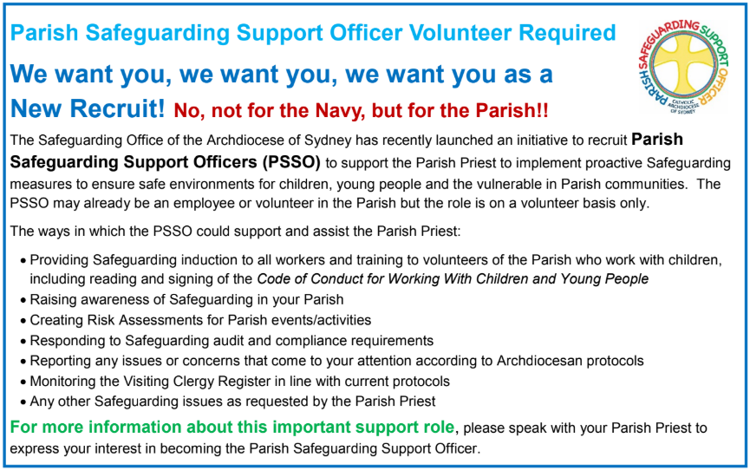

THE CATHOLIC ARCHDIOCESE OF SYDNEY SAFEGUARDING OFFICE
If you or a person close to you has been abused by someone working or ministering within the Archdiocese of Sydney we invite you to contact us. We will listen to you respectfully, offer support and discuss the options you have available to you. Please contact the Safeguarding and Ministerial Integrity Office on ph 02 9390 5812.

