SACRED HEART CHURCH
120 Carawatha Street Villawood
Telephone: (02) 9644-4026 Email: office@ihmsefton.org.au

Administrator: Fr Greg McGregor
Assistant Priest: Fr Thomas Alukka

SUNDAY MASS: Sunday – 9:00am
WEEKDAY MASSES: Tuesday to Friday – 8:00am
CONFESSIONS: On Request
BAPTISMS: Sunday 9:45am (Contact Parish Office)

Sunday, 10th February 2019: Fifth Sunday in Ordinary Time - Year C

ENTRANCE ANTIPHON: O come, let us worship God and bow low before the God who made us, for he is the Lord our God.
RESPONSORIAL PSALM: In the sight of the angels I will sing your praises, Lord.
GOSPEL ACCLAMATION: Alleluia, alleluia! Come follow me, says the Lord, and I will make you fishers of my people. Alleluia!
COMMUNION ANTIPHON: Let them thank the Lord for his mercy, his wonders for the children of men, for he satisfies the thirsty soul, and the hungry he fills with good things.

VILLAWOOD MASSES:
Monday – 11th February Our Lady of Lourdes. No Mass
Tuesday – 12th February 5th Week in Ordinary Time. No Mass.
Wednesday – 13th February 5th Week in Ordinary Time. Mass 8:00am
Thursday – 14th February Sts Cyril & Methodius. Mass 8:00am
Friday – 15th February 5th Week in Ordinary Time. Mass 8:00am
Saturday – 16th February Blessed Virgin Mary. No Mass
Sunday – 17th February 6th Week in Ordinary Time. Mass 9:00am

PLEASE NOTE THERE WILL BE NO MASS AT SACRED HEART VILLAWOOD ON TUESDAY 12TH FEBRUARY DUE TO A PRIEST CONFERENCE.

SEFTON MASSES: INDIAN MASSES AT VILLAWOOD:
Monday to Friday 9:15am Tuesday to Friday 7:00pm
Saturday 9:15am, 5:30pm (Vigil) Saturday 9:30am
Sunday 8:00am, 10:00am, 5:30pm Sunday 10:15am

Total of both collections last Sunday: $ 378.30

DEVOTIONS TO HONOUR OUR LADY OF LOURDES
Mass and Blessing of the Sick will be held at Our Lady of Lourdes Grotto, Earlwood, on Sunday 10th of February (behind Our Lady of Lourdes Church), entrance via St. James Avenue, Earlwood, commencing with recitation of the Rosary at 2:30pm followed by Mass and the Blessing of the Sick at 3:00pm. The Principal celebrant will be Bishop Terry Brady. Some parking for disabled people is available in the school grounds and general parking in the nearby council car park.
CATHOLIC WEEKLY - PULPIT POINTS 10th FEBRUARY 2018
• Marie Kondo’s gift to Vinnies
• Bishop slams Teacher’s Union
• Legendary Port Macquarie Priest passes away
• Charismatic leader visits Sydney
• Movie review: Roma
• To excommunicate ... or not
Available in the foyer. $2 – all money goes to the poor.

THANK YOU ST VINCENT DE PAUL VILLAWOOD
It is with great sadness that we must inform our parishioners that the Villawood branch of St Vincent de Paul has ceased operation. We would like to thank Wayne for over 45 years of service in the St Vincent de Paul Villawood society, having assisted countless families in our community. We would also like to thank the other Sacred Heart St Vincent de Paul members for their continued support over the years while St Vincent de Paul was active in our community; Margaret, Leonie and Frances. May you all be showered with blessings for your contribution to the less fortunate.

SACRED HEART PRIMARY SCHOOL YEAR 6 RECONCILIATION
On Thursday, 14th February, Year 6 will be participating in reconciliation at 10:30am. The Sacrament of Reconciliation should be prayerfully made with the spirit of humility.

PRO-LIFE TRAINING DAY WITH BRENDAN MALONE
Internationally renowned speaker Brendan Malone will run workshops on how to effectively participate in campaigns to defeat anti-life parliamentary bills – which could be introduced this year - and how to spread the pro-life message with clarity and compassion. We must prepare to combat this. The event is $30 per head and includes morning tea, lunch and afternoon tea. Saturday February 16, 9am to 5pm at an inner West location to be disclosed on registration. RSVP essential: www.trybooking.com/ZZAZ

MULTICULTURAL MASS 2019
A Mass at St Mary’s Cathedral at 2pm on Sunday 17th February, 2019 is to be held to celebrating interculturality. The Mass will be celebrated by His Grace, Archbishop Fisher. All are welcome.

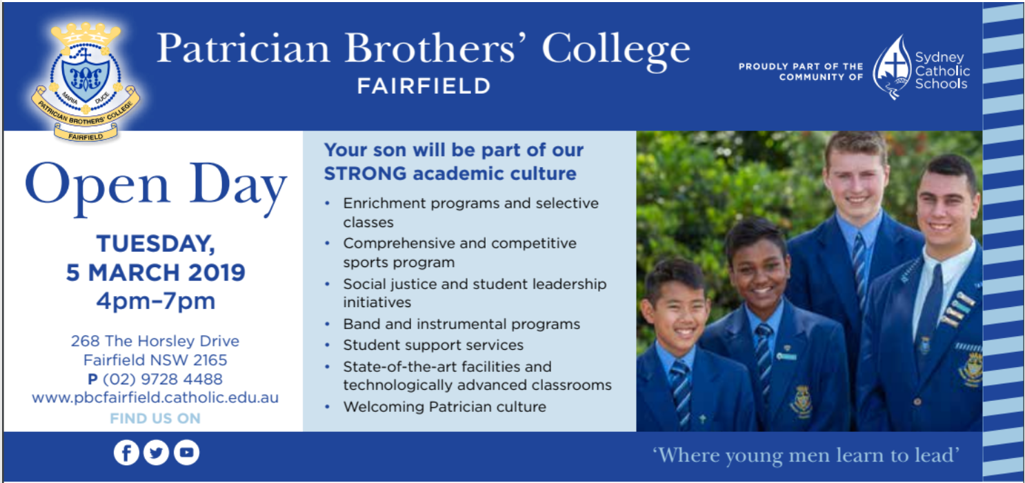

FOOTSTEPS OF ST PAUL:
Journey with St. Paul as you relive the Acts of the Apostles and the various letters of the New Testament. Explore Greece and Greek islands in this 14-day pilgrimage lead by Catholic Priests that features Athens, Corinth, Ephesus, Patmos, Crete, Santorini, Thessaloniki, Philippi and Meteora for an all-inclusive price of $5990. The group departs on 1st October 2019. The fare includes Return Economy Airfares + Local Transfers in Deluxe coaches + Stay in Premium Hotels + 4-day cruise with Lunch + All Breakfast & Dinners + Catholic Priest + English speaking professional guides + Entrances as per itinerary and more. Contact Parish Office for more details and booking information.

DO YOU NEED HELP CONNECTING WITH PROFESSIONAL CARE SERVICES?
Christmas can be a difficult time for families. CCareline helps Sydneysiders navigate the maze of social services and makes referrals to counsellors, therapists and case managers across Sydney. Call CCareline on 13 18 19.

CATHOLIC EDUCATION FUNDING
Would you like to receive a quality Catholic Education for your child? Is the cost of sending your child to a Catholic School holding you back from this? We are here to assist you however we can.
Do you live in government housing? Do you hold a current Health Care Card? Is your only source of income Centrelink? You could be eligible for heavily reduced fees.
If you don’t satisfy the above eligibility no need to panic, you still may be eligible for a reduction in your child’s school fees, if you are a low income worker. We will also help you set up payment plans for the small amount of fees you may be required to pay. All you will need to do is ask and our staff at your local Sydney Catholic School will be ready to assist you with this process, with the upmost of confidentiality.
For enquiries, please contact Sydney Catholic Schools, Southern Region Office, Mr Simon Wilson (Professional Officer, Assistant to the Regional Director) on (02) 9772 7000.

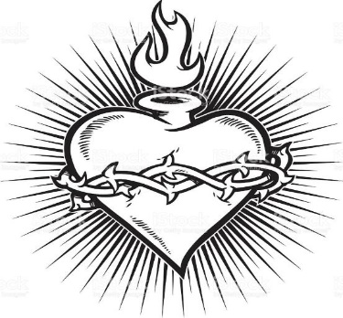

THE CATHOLIC ARCHDIOCESE OF SYDNEY SAFEGUARDING OFFICE
If you or a person close to you has been abused by someone working or ministering within the Archdiocese of Sydney we invite you to contact us. We will listen to you respectfully, offer support and discuss the options you have available to you. Please contact the Safeguarding and Ministerial Integrity Office on ph 02 9390 5812.

