SACRED HEART CHURCH
120 Carawatha Street Villawood
Telephone: (02) 9644-4026 Email: office@ihmsefton.org.au

Administrator: Fr Greg McGregor
Assistant Priest: Fr Thomas Alukka

SUNDAY MASS: Sunday – 9:00am
WEEKDAY MASSES: Tuesday to Friday – 8:00am
CONFESSIONS: On Request
BAPTISMS: Sunday 9:45am (Contact Parish Office)

Sunday, 24th February 2019: Seventh Sunday in Ordinary Time - Year C

ENTRANCE ANTIPHON: O Lord, I trust in your merciful love. My heart will rejoice in your salvation. I will sing to the Lord who has been bountiful with me.

RESPONSORIAL PSALM: The Lord is kind and merciful.

GOSPEL ACCLAMATION: Alleluia, alleluia! I give you a new commandment; love one another as I have loved you. Alleluia!

COMMUNION ANTIPHON: I will recount all your wonders, I will rejoice in you and be glad, and sing psalms to your name, O Most High.

VILLAWOOD MASSES:
Sunday – 24th February 7th Week in Ordinary Time. Mass 9:00am
Intentions of Youssef Rizk
Baptism of Isadora Nguyen after Mass.
Monday – 25th February 7th Week in Ordinary Time. No Mass
Tuesday – 26th February 7th Week in Ordinary Time. Mass 8:00am
Intentions of Eustine Loos
Wednesday – 27th February 7th Week in Ordinary Time. Mass 8:00am
Thursday – 28th February 7th Week in Ordinary Time. Mass 8:00am
Friday – 1st March Autumn Ember Day. Mass 8:00am
Saturday – 2nd March 7th Week in Ordinary Time. No Mass
Sunday – 3rd March 7th Week in Ordinary Time. Mass 9:00am
RIP Matild Riachi - Anniversary

SEFTON MASSES: INDIAN MASSES AT VILLAWOOD:
Monday to Friday 9:15am Tuesday to Friday 7:00pm
Saturday 9:15am, 5:30pm (Vigil) Saturday 9:30am
Sunday 8:00am, 10:00am, 5:30pm Sunday 10:15am

Total of both collections last Sunday: $394.65

BAPTISM OF ISADORA NGUYEN ON 24TH FEBRUARY
Please pray for Isadora Nguyen as we welcome her into our Parish community through the Sacrament of Baptism today. Let us pray also for her parents and Godparents, that the Lord may help them in raising Isadora in the practice of the faith.

CATHOLIC WEEKLY - PULPIT POINTS 24TH FEBRUARY 2019
• The beauty of God through the lens
• Vinnies sign up to homelessness plan
• US Cardinal busted back to lay state
• Movie review: Isn’t It Romantic
• Marriage prep worth its weight in gold
• Students’ legal win
Available in the foyer. $2 – all money goes to the poor.

PROJECT COMPASSION 2019
Many of us are very well aware of the significance of our Annual Project Compassion collection with its boxes, posters etc. This is a long-standing tradition in which we participate every Lent. It really is the Australian Church coming together to raise funds for the Third World and to ensure that we never fail to live in the awareness of the need to be aware of the needs of the less fortunate, especially those living in dire need due to starvation, war, natural disaster or location. It is a constant and necessary reminder of how blessed we are in living in our own society, an awareness that ought not to lead to any sense of superiority but rather leads us to a consciousness of our need to help others. It is also a marvellous opportunity to teach our children to think of others and to share a little of our good fortune as each family tries to keep the Project Compassion box in a prominent place in the home. Thank you to all who will participate once again this year.

ASH WEDNESDAY MASSES
Please note: Mass will be held at 9:15am (in place of the 8:00am Mass) with Yrs 3-6 from Sacred Heart Primary School in attendance on Ash Wednesday, 6th March. There will be a Mass at 7:00pm at Immaculate Heart of Mary Sefton Parish for any Parishioners who are unable to attend morning Mass.

SACRAMENTAL DATES FOR 2019
First Holy Communion: Sunday 18th August at 10:30am
First Reconciliation: Saturday 9th November at 10:00am
Confirmation: Tuesday 18th June at 6:00pm
Further information will be circulated closer to the dates.

SACRED HEART PRIMARY SCHOOL RECONCILIATION
On Thursday, 28th February, Year 4 will be participating in reconciliation at 10:30am. May the students find peace and fulfillment through the Sacrament of Reconciliation. The following week will see Year 3 students participate in this blessed Sacrament.

VOLUNTEERS NEEDED
St Joseph’s Hospital Auxiliary is in need of volunteers in their coffee shop. If interested, please call 9749-0295 between the hours of 10am and 3pm.

LEGION OF MARY
“Our Lady of Good Counsel” Cabramatta Curia
cordially invites you to celebrate our Annual Acies Ceremony

WHEN: Saturday, 02 March 2019 (Rosary 8:45 am; Mass 9:15 am)
Rev Fr. Gregory Mc Gregor, Parish Priest, Mass celebrant
WHERE: Immaculate Heart of Mary Catholic Church, Sefton
(6 Kerrinea Road, Sefton)

This year our annual Acies Ceremony coincides with 63 years Anniversary of Sefton Praesidium.

The “ACIES” is a Latin word meaning “as it does an army ranged in battle array”.
It is the annual Central Function in which legionaries as a body assemble to renew their fealty to Mary, Queen of the Legion, and from her receive strength and blessing for yet another year’s battle with the forces of evil. As a faithful Auxiliary member, you are encouraged to be present at this ceremony and, in union with active members, renew collectively and individually the Act of Consecration to Mary
All parishioners are cordially invited to attend Mass and morning tea in the Oblate Rooms.

SCHOLARSHIP AT THE CATHEDRAL
The Archdiocese of Sydney, together with Notre Dame University’s Institute for Ethics & Society have a number of engaging lectures featuring eminent international and Australian intellectuals coming up in 2019.
Please join us as the Archbishop of Sydney, Most Reverend Anthony Fisher OP delivers his second instalment of “The Godless Country? Part II, Christian Australia”.
“Are we living in a Christian country? Certainly, Christianity is the largest religious group in Australia. But where is the Church situated in the mind of modern Australia?” – Archbishop Anthony Fisher OP.
Date: Thursday, 7 March 2019
Time: 6:30pm
Venue: Chapter Hall, St Mary’s Cathedral
Refreshments provided.

RSVP’s Essential https://www.satcathedral.org/events/the-godless-country-part-ii/
More information events@sydneycatholic.org, 9390 5100

THE BISHOP’S BLEND
Looking to network with other young Catholic professionals and learn how to live your faith in the workplace? Then join the Most Reverend Bishop Richard Umbers, Auxiliary Bishop of Sydney on Monday, 11 March 2019 at 7:00am at the Radisson Blu Plaza Hotel Sydney for The Bishop’s Blend, a quarterly breakfast series for young professionals.
Online booking is essential. For more information and to purchase tickets go to https://thebishopsblendseventhedition.eventbrite.com.au or contact us at bishopsblend@sydneycatholic.org

DAY OF THE UNBORN CHILD
“I will not forget you, I have carved you on the palm of my hand.” Isaiah 49. The Family and Life Institute are holding their annual Day of the Unborn Child rally on Sunday, March 24. This is a day of celebration and remembrance of the dignity of the unborn. It is also a day to remember the millions of unborn children whose lives have been ended by abortion. Join us to witness to the sanctity of human life! 10:30am Mass at St. Mary’s Cathedral, 12pm Angelus, followed by a peaceful procession through the streets of the CBD led by Bishop Anthony Randazzo. 1:30pm Benediction at St. Mary’s Cathedral.

2019 BISHOP MANNING LECTURE – THE CATHOLIC COMMUNITY IN THE 21ST CENTURY
Where have we been? Where are we now? Where are we going? Who’s going with us? Listen to priest, academic, author and Vicar General of the Archdiocese of Canberra Goulburn, Father Anthony Percy speak on this topic of critical importance to the future of our Church. Named in honour of the Emeritus Bishop of Parramatta, Most Rev Kevin Manning, this annual lecture is hosted by the Catholic Commission for Employment Relations.
Date: Thursday 21 March 2019
Time: 6-8:30pm
Where: Kirribilli Club (Grand Ballroom), 11 Harbourview Crescent Lavender Bay.
Cost: Free
Registrations essential: ccercatholic.org.au/register

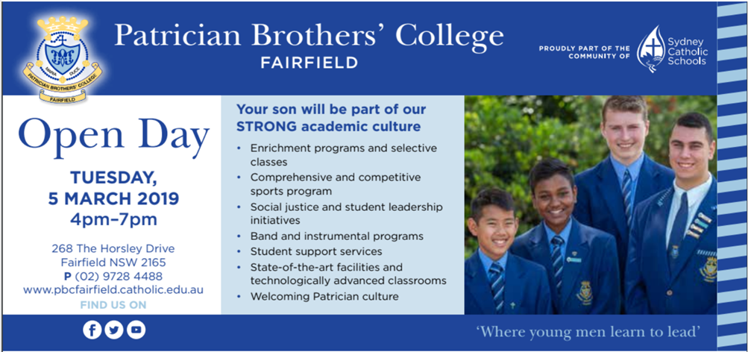

CATHOLIC EDUCATION FUNDING
Would you like to receive a quality Catholic Education for your child? Is the cost of sending your child to a Catholic School holding you back from this? We are here to assist you however we can.
Do you live in government housing? Do you hold a current Health Care Card? Is your only source of income Centrelink? You could be eligible for heavily reduced fees.
If you don’t satisfy the above eligibility no need to panic, you still may be eligible for a reduction in your child’s school fees, if you are a low income worker. We will also help you set up payment plans for the small amount of fees you may be required to pay. All you will need to do is ask and our staff at your local Sydney Catholic School will be ready to assist you with this process, with the upmost of confidentiality.
For enquiries, please contact Sydney Catholic Schools, Southern Region Office, Mr Simon Wilson (Professional Officer, Assistant to the Regional Director) on (02) 9772 7000.

COULD YOU HELP A CHILD IN NEED?
We urgently need compassionate people to provide short-term foster care. To learn more, come to our information night. Tuesday 5th March 2019, 5:30pm-8pm at CatholicCare 2C West Street (Cnr Thomas Street), Lewisham NSW 2049. Call CCareline on 13 18 19 to secure your place.

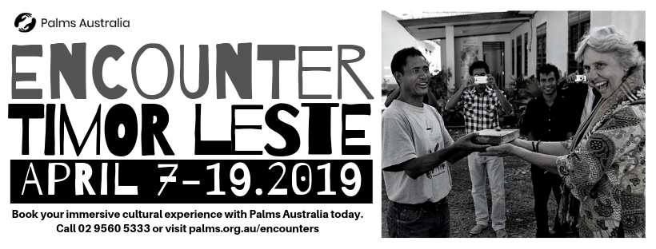

THE CATHOLIC ARCHDIOCESE OF SYDNEY SAFEGUARDING OFFICE
If you or a person close to you has been abused by someone working or ministering within the Archdiocese of Sydney we invite you to contact us. We will listen to you respectfully, offer support and discuss the options you have available to you. Please contact the Safeguarding and Ministerial Integrity Office on ph 02 9390 5812.

