SACRED HEART CHURCH
120 Carawatha Street Villawood
Telephone: (02) 9644-4026 Email: office@ihmsefton.org.au

Administrator: Fr Greg McGregor
Assistant Priest: Fr Thomas Alukka

SUNDAY MASS: Sunday – 9:00am
WEEKDAY MASSES: Tuesday to Friday – 8:00am
CONFESSIONS: On Request
BAPTISMS: Sunday 9:45am (Contact Parish Office)

Sunday, 3rd March 2019: Eighth Sunday in Ordinary Time - Year C

ENTRANCE ANTIPHON: The Lord became my protector. He brought me out to a place of freedom; he saved me because he delighted in me.

RESPONSORIAL PSALM: Lord, it is good to give thanks to you.

GOSPEL ACCLAMATION: Alleluia, alleluia! Shine on the world like bright stars; you are offering it the word of life. Alleluia!

COMMUNION ANTIPHON: I will sing to the Lord who has been bountiful with me, sing psalms to the name of the Lord Most High.

VILLAWOOD MASSES:
Sunday – 3rd March 8th Sunday in Ordinary Time. Family Mass 9:00am
RIP Matild Riachi (Anniversary)
Monday – 4th March St Casimir. No Mass
Tuesday – 5th February 8th Week in Ordinary Time. Mass 8:00am
For the Good Health of Marcus Jutrisa
Wednesday – 6th February Ash Wednesday. Mass 9:15am
Intentions of Leisa Farlow
Thursday – 7th February Sts Perpetua & Felicity. Mass 8:00am
RIP Gregory Sole (Anniversary)
Friday – 8th March St John of God. Mass 8:00am
RIP Shirley Galloway
Saturday – 9th March St Frances of Rome. No Mass
Sunday – 10th March 1st Sunday in Lent. Mass 9:00am
Healing Mass

SEFTON MASSES: INDIAN MASSES AT VILLAWOOD:
Monday to Friday 9:15am Tuesday to Friday 7:00pm
Saturday 9:15am, 5:30pm (Vigil) Saturday 9:30am
Sunday 8:00am, 10:00am, 5:30pm Sunday 10:45am

Total of both collections last Sunday: $683.80
CATHOLIC WEEKLY - PULPIT POINTS 3RD MARCH 2019
• All for the love of God: The Tyburn way
• Mary’s way with knots
• What men really need
• Cardinal George Pell convicted
• Movie review: Alita: Battle Angel
• Vatican Summit round-up
Available in the foyer. $2 – all money goes to the poor.

CARDINAL PELL CONVICTION
Dear Parishioners. No doubt you are aware of the distressing news this week of the conviction of Cardinal Pell in Victoria during the week. I am wary of bringing this up during mass out of concern for the young members of our community. I am happy to make myself available to anyone who would like to discuss this issue with me. There is also some material at the back of the Church if you are interested and I’m sure this week’s Catholic Weekly will have articles on the matter as well. Fr Greg.

ASH WEDNESDAY MASSES
Please note: Mass will be held at 9:15am (in place of the 8:00am Mass) with Yrs 3-6 from Sacred Heart Primary School in attendance on Ash Wednesday, 6th March. There will be a Mass at 7:00pm at Immaculate Heart of Mary Sefton Parish for any Parishioners who are unable to attend morning Mass.

STATIONS OF THE CROSS DURING LENT
Here at Sacred Heart there will be Stations of the Cross in Malayalam (Indian) at 7:00pm every Friday during Lent. At Immaculate Heart of Mary, Sefton, Stations of the Cross will be held every Thursday at 2:15pm as well as every Friday morning immediately after Mass (approximately 10am in place of Sacred Heart Devotions). All are welcome to attend.

FAMILY MASS FOR CATHOLIC SCHOOLS WEEK
On Sunday, 3rd March, we welcome members of our local Parish primary school. We join in celebration for a Family Mass to mark the beginning of Catholic Schools Week and pray for all students and teachers.

PROJECT COMPASSION 2019
Many of us are very well aware of the significance of our Annual Project Compassion collection with its boxes, posters etc. This is a long-standing tradition in which we participate every Lent. It really is the Australian Church coming together to raise funds for the Third World and to ensure that we never fail to live in the awareness of the need to be aware of the needs of the less fortunate, especially those living in dire need due to starvation, war, natural disaster or location. It is a constant and necessary reminder of how blessed we are in living in our own society, an awareness that ought not to lead to any sense of superiority but rather leads us to a consciousness of our need to help others. It is also a marvellous opportunity to teach our children to think of others and to share a little of our good fortune as each family tries to keep the Project Compassion box in a prominent place in the home. Thank you to all who will participate once again this year.

SISTERS OF THE IMMACULATA PRAYER GROUP FOR YOUNG ADULTS
The Immaculata Sisters at Sefton invite any young adults that are interested, to join them in prayer every fortnight at Immaculate Heart of Mary Sefton Parish. Starting on Friday March 15, the prayer group will begin in IHM Church at 6:30pm. The Sisters look forward to seeing some new faces!

SACRED HEART PRIMARY SCHOOL RECONCILIATION
On Thursday, 7th March, Year 3 will be participating in reconciliation at 10:30am. May the students find peace and fulfillment through the Sacrament of Reconciliation.

VOLUNTEERS NEEDED
St Joseph’s Hospital Auxiliary is in need of volunteers in their coffee shop. If interested, please call 9749-0295 between the hours of 10am and 3pm.

ST PATRICK’S DAY MASS
Bishop Terry Brady invites all parishioners to join him for the Annual St Patrick’s Day Mass on 17 March 2019 and 18 March 2019. The Masses will take place at St Patrick’s Church in Church Hill on Sunday, 17 March 2019 commencing at 12.00pm and in St Mary’s Cathedral, Sydney on Monday, 18 March 2019 commencing at 10:30am.

THE BISHOP’S BLEND
Looking to network with other young Catholic professionals and learn how to live your faith in the workplace? Then join the Most Reverend Bishop Richard Umbers, Auxiliary Bishop of Sydney on Monday, 11 March 2019 at 7:00am at the Radisson Blu Plaza Hotel Sydney for The Bishop’s Blend, a quarterly breakfast series for young professionals.
Online booking is essential. For more information and to purchase tickets go to https://thebishopsblendseventhedition.eventbrite.com.au or contact us at bishopsblend@sydneycatholic.org

2019 BISHOP MANNING LECTURE – THE CATHOLIC COMMUNITY IN THE 21ST CENTURY
Where have we been? Where are we now? Where are we going? Who’s going with us? Listen to priest, academic, author and Vicar General of the Archdiocese of Canberra Goulburn, Father Anthony Percy speak on this topic of critical importance to the future of our Church. Named in honour of the Emeritus Bishop of Parramatta, Most Rev Kevin Manning, this annual lecture is hosted by the Catholic Commission for Employment Relations.
Date: Thursday 21 March 2019
Time: 6-8:30pm
Where: Kirribilli Club (Grand Ballroom), 11 Harbourview Crescent Lavender Bay.
Cost: Free
Registrations essential: ccercatholic.org.au/register

DAY OF THE UNBORN CHILD
“I will not forget you, I have carved you on the palm of my hand.” Isaiah 49. The Family and Life Institute are holding their annual Day of the Unborn Child rally on Sunday, March 24. This is a day of celebration and remembrance of the dignity of the unborn. It is also a day to remember the millions of unborn children whose lives have been ended by abortion. Join us to witness to the sanctity of human life! 10:30am Mass at St. Mary’s Cathedral, 12pm Angelus, followed by a peaceful procession through the streets of the CBD led by Bishop Anthony Randazzo. 1:30pm Benediction at St. Mary’s Cathedral.

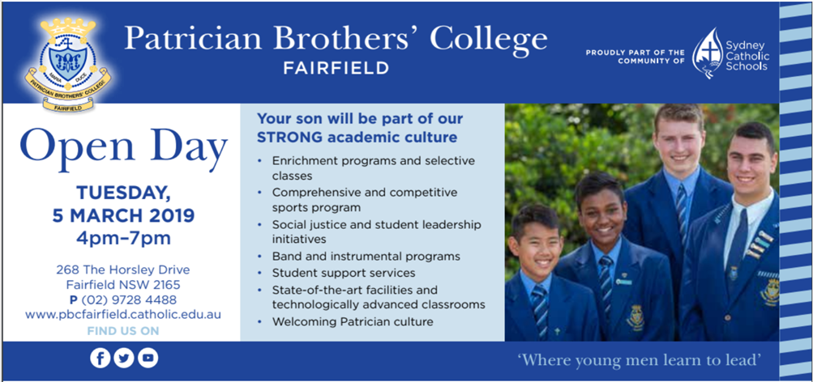

MEN’S MINISTRY NETWORK MEETING
On Saturday morning, March 16, a men’s breakfast gathering is to be held. Commencing with Adoration of the Blessed Sacrament at 8am, followed by Mass at 8:30am with Bishop Anthony Randazzo, a BBQ breakfast at 9:30am and a presentation at 10am from Robert Haddad on how he stayed connected with his faith as a young man and benefits of brotherhood with other good men. Venue is St Christopher’s Parish, Panania. Cost is $10 per head to cover the food. Bookings: www.trybooking.com/BAACH

COULD YOU HELP A CHILD IN NEED?
We urgently need compassionate people to provide short-term foster care. To learn more, come to our information night. Tuesday 5th March 2019, 5:30pm-8pm at CatholicCare 2C West Street (Cnr Thomas Street), Lewisham NSW 2049. Call CCareline on 13 18 19 to secure your place.

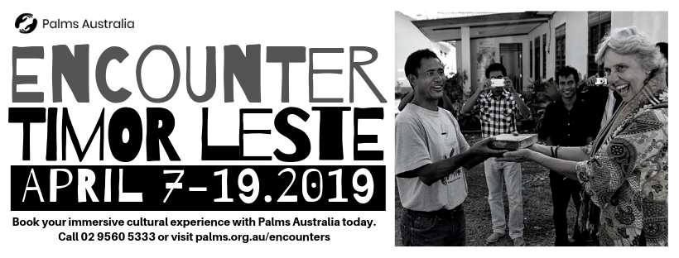

THE CATHOLIC ARCHDIOCESE OF SYDNEY SAFEGUARDING OFFICE
If you or a person close to you has been abused by someone working or ministering within the Archdiocese of Sydney we invite you to contact us. We will listen to you respectfully, offer support and discuss the options you have available to you. Please contact the Safeguarding and Ministerial Integrity Office on ph 02 9390 5812.

